**Difference Between Active and Passive Components**

**What are active components?** These components are parts of a circuit that rely on an external power source to control or modify electrical signals. Active components such as transistors and silicon-controlled rectifiers (SCRs) use electricity to control electricity.

**What are passive components?** Like resistors, transformers, and [**diodes**](https://www.arrow.com/en/categories/diodes-transistors-and-thyristors) don’t need an external power source to function. These components use some other property to control the electrical signal. As a result, they only require the current traveling through the connected circuit. Resistors impede the flow of electrons without introducing more electricity into the system.

## Active Components

An **active component** is an electronic component which supplies energy to a circuit.

Common examples of active components include:

* Voltage sources
* Current sources
* Generators (such as alternators and DC generators)
* All different types of transistors (such as bipolar junction transistors, MOSFETS, FETs, and JFET)
* Diodes (such as Zener diodes, photodiodes, Schottky diodes, and LEDs)

### **Voltage Sources**

A voltage source is an example of an active component in a circuit. When current leaves from the positive terminal of the voltage source, energy is being supplied to the circuit. As per the definition of an active element, a battery can also be considered as an active element, as it continuously delivers energy to the circuit during discharging.

### **Current Sources**

A current source is also considered an active component. The current supplied to the circuit by an ideal current source is independent of circuit voltage. As a current source is controlling the flow of charge in a circuit, it is classified as an active element.

### **Transistors**

Although not as obvious as a current or voltage source – transistors are also an active circuit component. This is because transistors are able to amplify the power of a signal (see our article on transisors as an amplifier if you want to know exactly how).

## Passive Components

A **passive component** is an electronic component which can only receive energy, which it can either dissipate, absorb or store it in an electric field or a magnetic field. Passive elements do not need any form of electrical power to operate.

As the name ‘passive’ suggests – passive devices do not provide gain or amplification. Passive components cannot amplify, oscillate, or generate an electrical signal.

Common examples of passive components include:

* Resistors
* Inductors
* Capacitors
* Transformers

### **Resistors**

A resistor is taken as a passive element since it can not deliver any energy to a circuit. Instead resistors can only receive energy which they can dissipate as heat as long as current flows through it.

### **Inductors**

An inductor is also considered as passive element of circuit, because it can store energy in it as a magnetic field, and can deliver that energy to the circuit, but not in continuous basis. The energy absorbing and delivering capacity of an inductor is limited and transient in nature. That is why an inductor is taken as a passive **element of a circuit**.

### **Capacitors**

A capacitor is considered as a passive element because it can store energy in it as electricfield. The energy dealing capacity of a capacitor is limited and transient – it is not actually supplying energy, it is storing it for later use.

As such it is not considered an active component since no energy is being supplied or amplified.

### **Transformers**

A transformer is also a passive electronic component. Although this can seem surprising since transformers are often used to raise voltage levels – remember that power is kept constant.

When transformers step up (or step down) voltage, power and energy remain the same on the primary and secondary side. As energy is not actually being amplified – a transformer is classified as a passive element.

## What is an AC Generator?

AC generator is a machine that converts mechanical energy into electrical energy. The AC Generator’s input supply is mechanical energy supplied by steam turbines, gas turbines and combustion engines. The output is alternating electrical power in the form of alternating voltage and current.

AC generators work on the principle of [Faraday’s law of electromagnetic induction](https://byjus.com/physics/faradays-law/), which states that electromotive force – EMF or voltage – is generated in a current-carrying conductor that cuts a uniform magnetic field. This can either be achieved by rotating a conducting coil in a static magnetic field or rotating the magnetic field containing the stationary conductor. The preferred arrangement is to keep the coil stationary because it is easier to draw induced alternating current from a stationary armature coil than from a rotating coil.

**The generated EMF depends on the number of armature coil turns, magnetic field strength, and the speed of the rotating field.**

### **AC Generator Parts and Function**

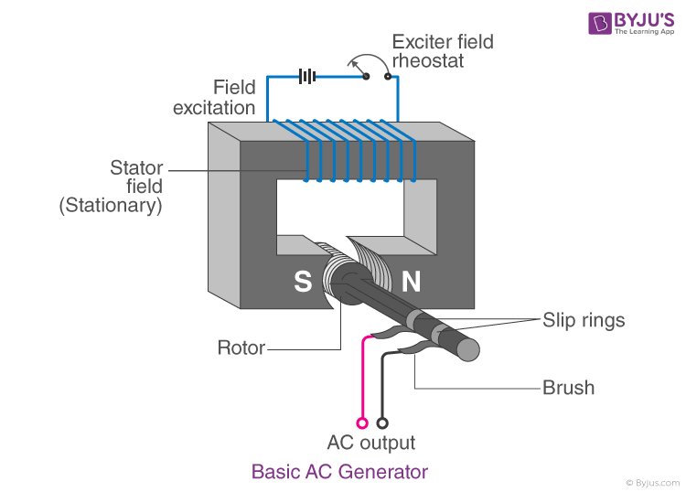

The various parts of an AC generator are:

* Field
* Armature
* Prime Mover
* Rotor
* Stator
* Slip Rings

The following are the functions of each of these components of an AC generator.

### **Field**

The field consists of coils of conductors that receive a voltage from the source and produce magnetic flux. The magnetic flux in the field cuts the armature to produce a voltage. This voltage is the output voltage of the AC generator.

### **Armature**

The part of an AC generator in which the voltage is produced is known as an armature. This component primarily consists of coils of wire that are large enough to carry the full-load current of the generator.

### **Prime Mover**

The component used to drive the AC generator is known as a prime mover. The prime mover could either be a diesel engine, a steam turbine, or a motor.

### **Rotor**

The rotating component of the generator is known as a rotor. The generator’s prime mover drives the rotor.

### **Stator**

The stator is the stationary part of an AC generator. The stator core comprises a lamination of steel alloys or magnetic iron to minimise the [eddy current losses](https://byjus.com/physics/what-are-eddy-currents/).

### **Slip Rings**

Slip rings are electrical connections used to transfer power to and fro from the rotor of an AC generator. They are typically designed to conduct the flow of current from a stationary device to a rotating one.

### **Working of an AC Generator**

When the armature rotates between the poles of the magnet upon an axis perpendicular to the magnetic field, the flux linkage of the armature changes continuously. As a result, an electric current flows through the galvanometer and the slip rings and brushes. The galvanometer swings between positive and negative values. This indicates that there is an alternating current flowing through the galvanometer. The direction of the induced current can be identified using [Fleming’s Right-Hand Rule](https://byjus.com/physics/flemings-left-hand-rule-and-right-hand-rule/).

## What is a DC Generator?

A DC generator is an electrical machine whose main function is to convert mechanical energy into electricity. When the conductor slashes magnetic flux, an emf will be generated based on the electromagnetic induction principle of Faraday’s Laws. This electromotive force can cause a flow of current when the conductor circuit is closed.

### **Parts of a DC Generator**

A DC generator can also be used as a DC motor without changing its construction. Therefore, a DC motor, otherwise a DC generator, can be generally called a DC machine. Below we have mentioned the essential parts of a DC Generator.

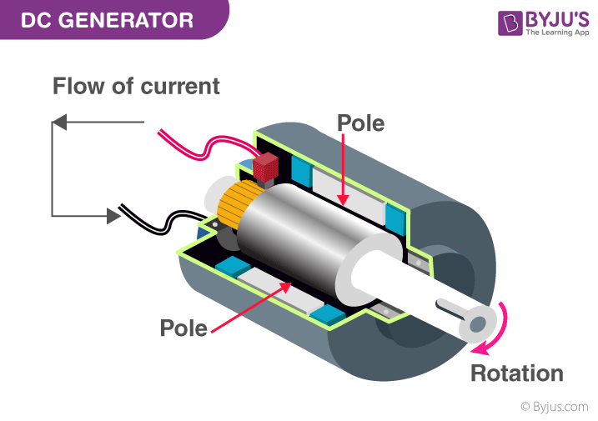

Parts of a DC Generator

#### **Stator**

The main function of the stator is to provide magnetic fields where the coil spins. A stator includes two magnets with opposite polarities facing each other. These magnets are located to fit in the region of the rotor.

#### **Rotor**

A rotor in a DC machine includes slotted iron laminations with slots that are stacked to shape a cylindrical armature core. The function of the lamination is to decrease the loss caused due to [eddy current](https://byjus.com/physics/what-are-eddy-currents/).

#### **Armature Windings**

Armature windings are in a closed circuit form and are connected in series to parallel to enhance the produced current sum.

#### **Yoke**

The external structure of the DC generator is known as Yoke. It is made of either cast iron or steel. It provides the necessary mechanical power for carrying the magnetic flux given through the poles.

#### **Poles**

The function of a pole is to hold the field windings. These windings are wound on poles and are either connected in series or parallel by the armature windings.

#### **Pole Shoe**

Pole shoe is mainly utilized for spreading the magnetic flux to prevent the field coil from falling.

#### **Commutator**

A commutator works like a rectifier that changes AC voltage to DC voltage within the armature winding. It is designed with a copper segment, and each copper segment is protected from the other with the help of mica sheets. It is located on the shaft of the machine.

#### **Brushes**

The electrical connections can be ensured between the commutator as well as the exterior load circuit with the help of brushes.

### **How does a DC Generator Work?**

According to [Faraday’s law of electromagnetic induction](https://byjus.com/physics/faradays-law/), we know that when a current-carrying conductor is placed in a varying magnetic field, an emf is induced in the conductor. According to Fleming’s right-hand rule, the direction of the induced current changes whenever the direction of motion of the conductor changes. Let us consider an armature rotating clockwise and a conductor at the left moving upwards. When the armature completes a half rotation, the direction of the motion of the conductor will be reversed downward. Hence, the direction of the current in every armature will be alternating. But with a split ring commutator, connections of the armature conductors get reversed when a current reversal occurs. Therefore, we get a unidirectional current at the terminals.

**Read more about Fleming’s right-hand rule**[**here**](https://byjus.com/physics/flemings-left-hand-rule-and-right-hand-rule/)**.**

### **E.M.F Equation of DC generator**

The emf equation of the DC generator is given by the equation:

Eg=PϕZN60A

where

**Z** is the total number of armature conductor

**P** is the number of poles in a generator

**A** is the number of parallel lanes within the armature

**N** is the rotation of armature in r.p.m

**E** is the induced e.m.f in any parallel lane within the armature

**Eg** is the generated e.m.f in any one of the parallel lane

**N**/**60** is the number of turns per second

The time for one turn will be dt=60/N sec.

## Losses in DC Generator

The input power is not fully transformed into the output power in a DC machine. Some part of input power gets wasted in various forms. In a DC machine, the losses are broadly classified into four types:

* **Copper Loss**  
  Copper loss takes place when the current flows through the winding. These losses occur due to the resistance in the winding. The copper loss is categorized into three forms armature loss, the field winding loss and brush contact resistance loss.
* **Core Losses or Iron Losses**  
  Some losses in the iron core occur when the armature rotates in the magnetic field. These losses are known as core losses. These losses are categorized into two losses as Hysteresis loss and Eddy current loss.

## Types of DC generator

The DC generator can be classified into two main categories as separately excited and self-excited.  
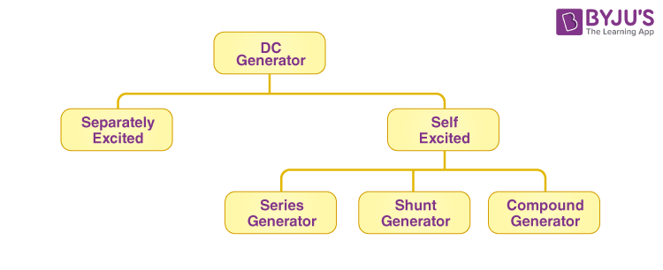

### **Separately Excited**

The field coils are energized from an independent exterior DC source in a separately excited type generator.

### **Self Excited**

In a self-excited type, the field coils are energized from the generated current within the generator. These types of generators can further be classified into a **series of wounds**, **shunt-wound**, and **compound wound**.

## Applications of DC Generators

A few applications of DC generators are:

* The separately excited type DC generators are used for power and lighting purposes.
* The series DC generator is used in arc lamps for lighting, stable current generator and booster.
* DC generators are used to reimburse the voltage drop within Feeders.
* DC generators are used to provide a power supply for hostels, lodges, offices, etc.

This was a comprehensive explanation about DC generators. From the information above, we can conclude that the main advantages of a DC generator are its simple construction and design.

## What is an AC Motor?

An AC motor is a motor that converts alternating current into mechanical power. The stator and the rotor are important parts of AC motors. The stator is the stationary part of the motor, and the rotor is the rotating part of the motor. The AC motor may be single-phase or three-phase. Nikola Tesla invented the first AC induction motor in 1887.

## Construction of an AC motor

An alternating current drives an AC motor. The stationary stator and the rotating rotor are important parts of AC motors. In this section, let us study the different parts of an AC motor.

### **AC Motor Diagram**

Following are the different parts of an AC motor:

### **Stator**

The stator is the stationary part of the motor that delivers a rotating magnetic field to interact with the rotor.

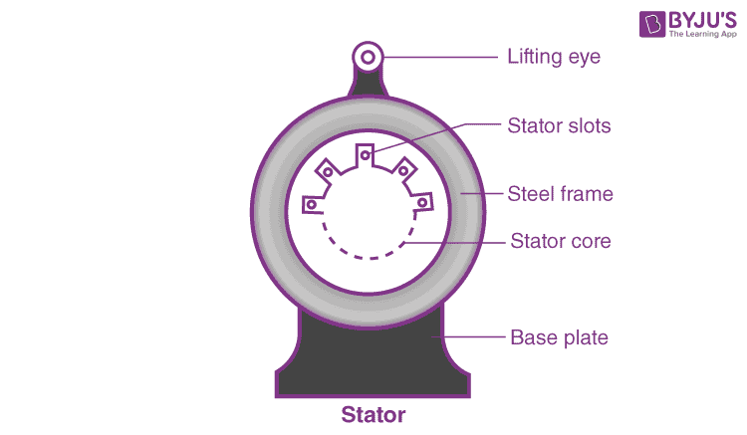

#### **Stator Core**

The stator core is made of thin metal sheets known as laminations. Laminations are used to reduce energy loss.

#### **Stator Windings**

Stator windings are stacked together, forming a hollow cylinder. The slots of the stator core coils of insulated wires are insulated.

When the assembled motor operates, the stator windings are connected to a power source. Each group of coils, along with the steel core, becomes an electromagnet when the current is applied.

### **Rotor**

A rotor is a central component of a motor that is fixed to the shaft. The most common type of rotor used in an AC motor is the squirrel cage rotor. A squirrel-cage rotor is cylindrical and is made by stacking thin steel laminations.

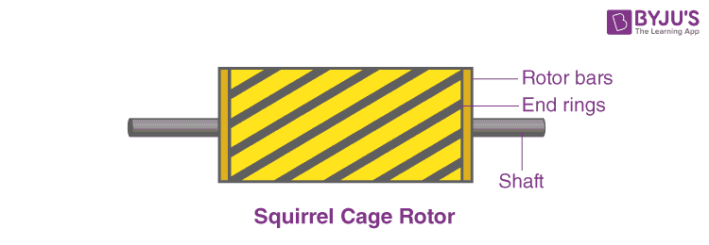

Instead of inserting wire coils between the slots, conductor bars are die-cast into the evenly spaced slots around the cylinder. Once the conductor bars are die-casted, they are electrically and mechanically connected to the end rings.

### **Motor Shaft**

The rotor is pressed onto a steel shaft to form a rotor assembly. The shaft extends outside the motor casing allowing connection to an external system to transmit the rotational power.

### **Bearings**

Bearings hold the motor shaft in place. The bearings minimize the shaft’s friction connected to the casing, which increases the motor’s efficiency.

### **Enclosure**

The enclosure protects the internal parts of the motor from water and other environmental elements. The enclosure consists of a frame and two end brackets.

## Classification of AC Motor

Below, we have discussed the different types of AC motors in detail.

**Based on the principle of operation, AC motors are classified as:**

* Synchronous Motor
* Induction Motor

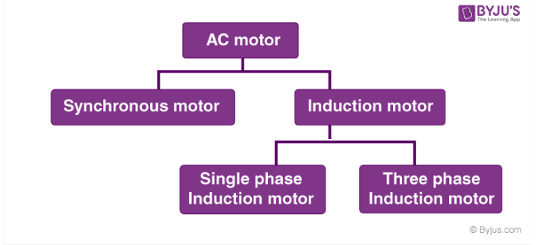

## Synchronous Motor

The motor that runs at synchronous speed is known as the synchronous motor. The constant speed at which the motor generates the electromotive force is known as synchronous speed. An electromagnet in the rotating magnetic field magnetically locks itself with the rotating magnetic field and rotates simultaneously with the rotating field. This is where the name synchronous motor comes from. This also means that synchronous motors have fixed speeds. The synchronous speed can be calculated using the following formula:

#### **AC Motor Synchronous Speed Formula**

ns=120fp

where ns is the synchronous speed, f is the line voltage frequency in Hz, and P is the number of poles.

### **Working Principle of a Synchronous Motor**

* The synchronous motor works with two electrical inputs provided to it.
* The stator is equipped with a 3-phase AC supply, while the rotor is provided with the DC supply.
* The stator winding supplied with 3 phase AC supply generates 3 phase rotating magnetic flux. The rotor carrying DC supply produces a constant flux.
* At a particular instant, the rotor and the stator poles might be of the same polarity (N-N or S-S), causing a repulsive force and the very next second, it will be N-S causing an attractive force.
* Due to this attractive and repulsive force, the motor cannot rotate in any direction and remains in a standstill position.
* To overcome this resistance to motion, the rotor is initially fed mechanical input that rotates it in the same direction as the magnetic field. After some time, magnetic locking occurs, and the synchronous motor rotates in synchronism.

## Induction Motor

Induction motors are the most commonly used motors. Induction motors are also known as asynchronous motors because they always run slower than synchronous speed.

Based on the type of rotor construction, they are divided into two types as follows:

* **Squirrel Cage Motor**
* **Slip Ring Motor**

### **Working Principle of Induction Motors**

* In an induction motor, the stator winding is fed with an AC supply. This causes the stator winding to develop an alternating flux. We call this rotating flux “Rotating Magnetic Field (RMF).”
* According to Faraday’s Law of Electromagnetic Induction, the relative speed between the stator RMF and the rotor RMF causes an induced emf in the rotor conductors. Rotor conductors are short-circuited, and a rotor current is produced due to induced emf.
* This induced current produces alternating flux around it. It should be noted that the stator flux lags behind the rotor flux.
* Due to the relative velocity between the rotating stator flux and the rotor, the rotor rotates in the same direction as that of the stator flux to minimize the relative velocity. This is the basic working principle of the induction motor.
* The difference between the synchronous speed (Ns) and the actual speed (N) of the rotor is known as the slip.

## Applications of AC Motors

AC motors are a preferred source of supply due to the following reasons:

#### **Longevity**

With only a few moving parts, AC motors have the potential to last for years. The durability of AC motors makes them a preferred solution for field applications such as agricultural equipment and commercial applications such as vending machines.

#### **Efficiency**

The speed-to-torque characteristics of AC motors allow them to provide excellent performance in many applications without overheating, degeneration or braking. This is why an AC motor is chosen for high-demand applications such as pumps and packaging equipment.

#### **Quiet Operation**

Producing less noise, AC motors are ideal for applications in stores, hospitals and restaurants.

#### **Availability**

AC motors are available in a wide range of sizes and power outputs. This wide range makes it ideal for many applications.

## What is a DC Motor?

**A DC motor is defined as a class of electrical motors that convert direct current electrical energy into mechanical energy.**

From the above definition, we can conclude that any electric motor that is operated using direct current or DC is called a DC motor. We will understand the DC motor construction and how a DC motor converts the supplied DC electrical energy into mechanical energy in the next few sections.

### **DC Motor Diagram**

#### **DC Motor Parts**

### **Different Parts of a DC Motor**

A DC motor is composed of the following main parts::

### **Armature or Rotor**

The armature of a DC motor is a cylinder of magnetic laminations that are insulated from one another. The armature is perpendicular to the axis of the cylinder. The armature is a rotating part that rotates on its axis and is separated from the field coil by an air gap.

### **Field Coil or Stator**

A DC motor field coil is a non-moving part on which winding is wound to produce a [magnetic field](https://byjus.com/physics/magnetic-field/). This electro-magnet has a cylindrical cavity between its poles.

### **Commutator and Brushes**

**Commutator**

The commutator of a DC motor is a cylindrical structure that is made of copper segments stacked together but insulated from each other using mica. The primary function of a commutator is to supply electrical current to the armature winding.

**Brushes**

The brushes of a DC motor are made with graphite and carbon structure. These brushes conduct electric current from the external circuit to the rotating commutator. Hence, we come to understand that the **commutator and the brush unit are concerned with transmitting the power from the static electrical circuit to the mechanically rotating region or the rotor**.

## DC Motor Working

In the previous section, we discussed the various components of a DC motor. Now, using this knowledge let us understand the working of DC motors.

A magnetic field arises in the air gap when the field coil of the DC motor is energised. The created magnetic field is in the direction of the radii of the armature. The magnetic field enters the armature from the North pole side of the field coil and “exits” the armature from the field coil’s South pole side.

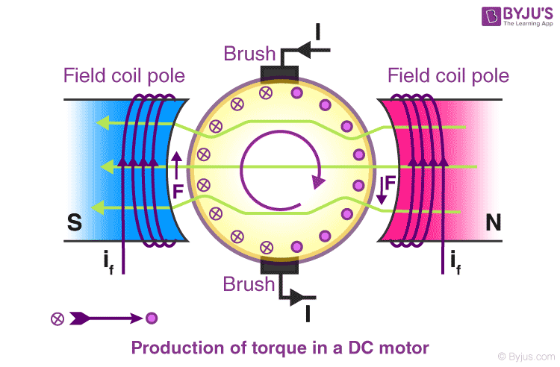

The conductors located on the other pole are subjected to a force of the same intensity but in the opposite direction. These two opposing forces create a [torque](https://byjus.com/physics/torque/) that causes the motor armature to rotate.

|  |
| --- |
| **Working principle of DC motor**  When kept in a magnetic field, a current-carrying conductor gains torque and develops a tendency to move. In short, when electric fields and magnetic fields interact, a mechanical force arises. This is the principle on which the DC motors work. |
| **Similar Reading** |
| [DC Generator](https://byjus.com/physics/dc-generator/) |
| [AC Generator](https://byjus.com/physics/ac-generator/) |
| [Universal Motor](https://byjus.com/physics/universal-motor/) |

## Types of DC motor

DC motors have a wide range of applications ranging from electric shavers to automobiles. To cater to this wide range of applications, they are classified into different types based on the field winding connections to the armature as:

* Self Excited DC Motor
* Separately Excited DC Motor

Now, let us discuss the various types of DC Motors in detail.

### **Self Excited DC Motor**

In self-excited DC motors, the field winding is connected either in series or parallel to the armature winding. Based on this, the self-excited DC motor can further be classified as:

* Shunt wound DC motor
* Series wound DC motor
* Compound wound DC motor

#### **Shunt wound DC motor**

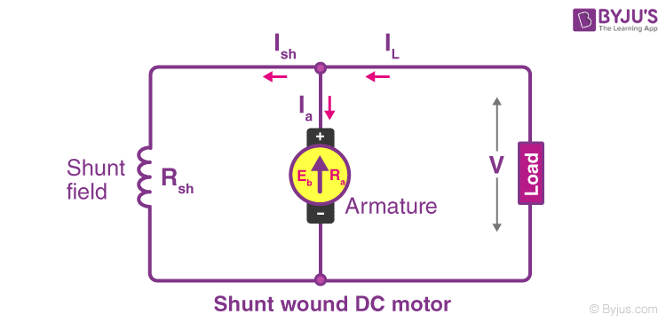

In a shunt wound motor, the field winding is connected parallel to the armature as shown in the figure.

#### **Series wound DC motor**

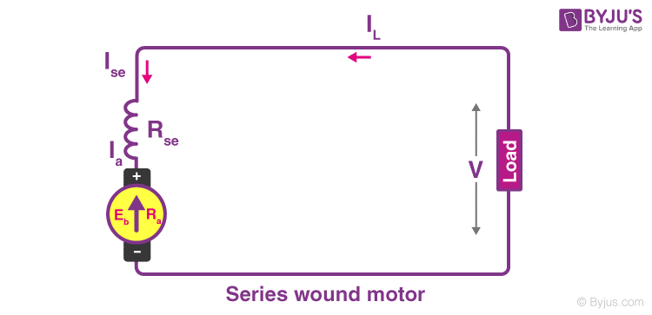

In a series wound DC motor, the field winding is connected in series with the armature winding as shown in the figure.

#### **Compound wound DC motor**

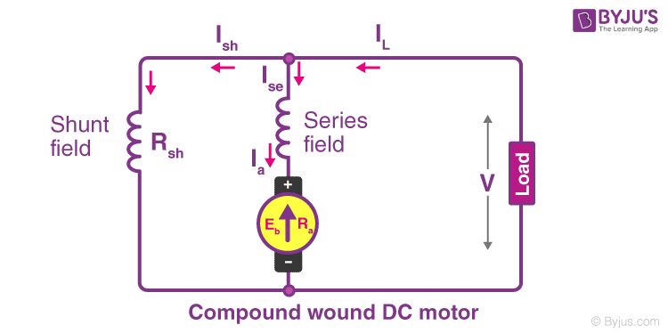

DC motors having both shunt and series field winding is known as Compound DC motor, as shown in the figure. The compound motor is further divided into:

* Cumulative Compound Motor
* Differential Compound Motor

In a cumulative compound motor, the magnetic flux produced by both the windings is in the same direction. In a differential compound motor, the flux produced by the series field windings is opposite to the flux produced by the shunt field winding.

### **Separately Excited DC Motor**

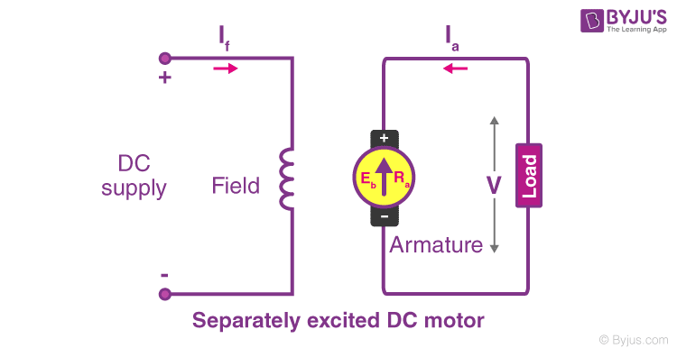

In a separately excited DC motor, the field coils are energised from an external source of DC supply as shown in the figure.

## Brushed DC Motor vs Brushless DC Motor

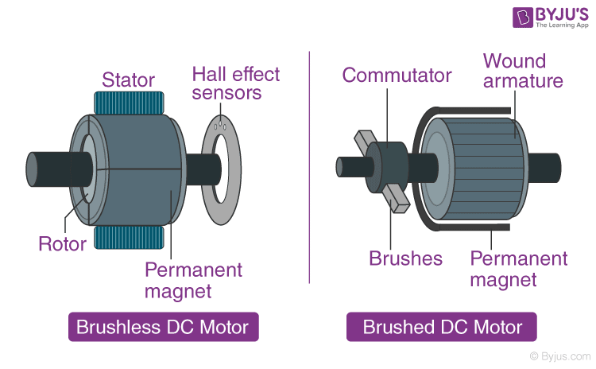

A brushless DC motor, also known as synchronous DC motor, unlike brushed DC motors, do not have a commutator. The commutator in a brushless DC motor is replaced by an electronic servomechanism that can detect and adjust the angle of the rotor.

A brushed DC motor features a commutator that reverses the current every half cycle and creates single direction torque. While brushed DC motors remain popular, many have been phased out for more efficient brushless models in recent years.

## Applications of DC Motor

The applications of different types of DC motors are listed below:

#### **Shunt DC Motors**

Owing to the fairly constant speed and medium starting torque of shunt DC motors, they are used in the following applications:

1. Centrifugal and reciprocating pumps
2. Lathe machines
3. Blowers and Fans
4. Drilling machines
5. Milling machines
6. Machine tools

#### **Series DC Motors**

Owing to the high starting torque and variable speed of series DC motors, they are used in the following applications:

* Conveyors
* Hoists, Elevators
* Cranes
* Electric Locomotives

#### **Cumulative Compound DC motors**

Owing to the high starting torque of cumulative compound DC motors, they are used in the following applications:

* Shears
* Heavy Planers
* Rolling mills
* Elevators

# **Timers | All you need to know: Types, Operating Mode, Applications**

**Timers:**Timers are used to measure specific time intervals. But in electrical engineering terms, timers are also referred to as counters often. The timer is a component which is extensively used in different embedded systems. They are used to keep a record of time for different events occurring in the embedded systems. The timer is a simpler binary counter which is configured in a circuit or a system as per the need to count the pulses in the system. The value of the timer is automatically set to zero once it is at its maximum value. Once the maximum value for the timer is reached, an interrupt is generated with an overflow flag. The timer can be used to measure the time elapsed or the external events occurring for a specific time interval. They are used to maintain the operation of the embedded system in sync with the clock. The clock can be an external clock or the system clock. Timers are used for various applications in circuits or embedded systems such as to generate baud rates, measuring time generating delays and many more. The loop iterating methodologies are very difficult and they can iterate the loops in the system for a specific range of cycles. For the iteration of loops perfectly and systematically timer/counters are used. The timer is very easy to be program instead of different programming practices for loop iterations. The timer counts the peripheral clock cycles or it can count the clock cycles of the externally supplied clock. Clock pulses can be also generated with the help of timers which is also called the Baud Rate of the serial communication.

## Types of Timers:

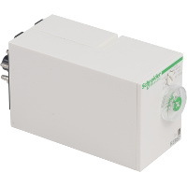

Types of timers

There are two main categories in which timers are classified:

* **Analog Timers:**

The analog timers are those timers which are set up by knobs and their output is observed with analog scale. The timing functionalities and scale of an analog timer are easily adjusted with the help of switches mounted on the front side of the timer.

* **Digital Timers:**

Digital timers are adjusted and controlled with the help of digital inputs and their output is also observed with the digital scales. The different buttons are used to set up the timing and set points of a timer. The output is displayed through the LCD mounted on the timer.

## Operating Mode

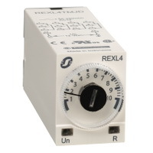

4 basic operating modes for a timer

There are 4 basic operating modes for a timer which are:

* ON-Delay Operation.
* OFF-Delay Operation.
* Flicker Operation.
* Interval Operation.

### ON-Delay Operation:

In this mode of operation, the timer counts the output of the system after a specific interval of the specified delay. The timer is named as ON delay timer as there is some delay before the input signal is turned ON. ON delay timer mode of operation is used with the automated machines.

### OFF-Delay Operation:

In OFF delay operation, the timer starts its operation as soon as the input starts, the output is also started but the output of the timer is stopped once the set time of the timer has expired. The set time of the timer is calculated once the input is turns OFF. The basic example of OFF delay timer is the gate indicator light in the cars.

## Applications of Timers

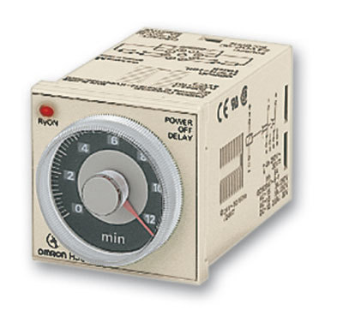

Timer’s circuits have different applications in different systems

Timer’s circuits have different applications in different systems. Timers are used for various purposes in the circuit. In a counter circuit, the major part of the circuit is a timer.  The speed of the circuit can be changed by changing the timer’s time period. Timers are used to generate the desired delays, baud rates are also generated with the help of timers. Timers are also used as reference signal generators. Different reference pulses are generated with the help of timers. A number of flip flop circuits are triggered by different timers. The event sequence is easily controlled with the help of timers. A timer has various applications which are extensively used in daily life practical devices from the basic household level to a large industrial level. Each timer has its own applications and characteristics.

# 555 Timer Tutorial

The 555 Timer is a commonly used IC designed to produce a variety of output waveforms with the addition of an external RC network

We have seen that Multivibrators and CMOS Oscillators can be easily constructed from discrete components to produce relaxation oscillators for generating basic square wave output waveforms. But there are also dedicated IC’s such as the 555 timer especially designed to accurately produce the required output waveform with the addition of just a few extra timing components.

One such device that has been around since the early days of IC’s and has itself become something of an industry “standard” is the **555 Timer Oscillator** which is more commonly called the **“555 Timer”**.

The basic **555 timer** gets its name from the fact that there are three internally connected 5kΩ resistors which it uses to generate the two comparators reference voltages. The 555 timer IC is a very cheap, popular and useful precision timing device which can act as either a simple timer to generate single pulses or long time delays, or as a relaxation oscillator producing a string of stabilised waveforms of varying duty cycles from 50 to 100%.

The 555 timer chip is extremely robust and stable 8-pin device that can be operated either as a very accurate Monostable, Bistable or Astable Multivibrator to produce a variety of applications such as one-shot or delay timers, pulse generation, LED and lamp flashers, alarms and tone generation, logic clocks, frequency division, power supplies and converters etc, in fact any circuit that requires some form of time control as the list is endless.

The single 555 Timer chip in its basic form is a Bipolar 8-pin mini Dual-in-line Package (DIP) device consisting of some 25 transistors, 2 diodes and about 16 resistors arranged to form two comparators, a flip-flop and a high current output stage as shown below. As well as the 555 Timer there is also available the NE556 Timer Oscillator which combines TWO individual 555’s within a single 14-pin DIP package and low power CMOS versions of the single 555 timer such as the 7555 and LMC555 which use MOSFET transistors instead.

A simplified “block diagram” representing the internal circuitry of the **555 timer** is given below with a brief explanation of each of its connecting pins to help provide a clearer understanding of how it works.

### 555 Timer Block Diagram

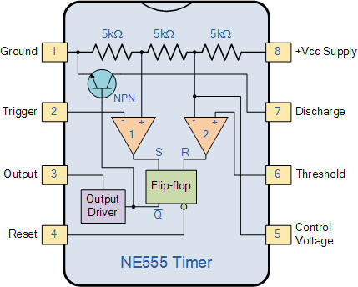

* • Pin 1. – **Ground**, The ground pin connects the 555 timer to the negative (0v) supply rail.
* • Pin 2. – **Trigger**, The negative input to comparator No 1. A negative pulse on this pin “sets” the internal Flip-flop when the voltage drops below 1/3Vcc causing the output to switch from a “LOW” to a “HIGH” state.
* • Pin 3. – **Output**, The output pin can drive any TTL circuit and is capable of sourcing or sinking up to 200mA of current at an output voltage equal to approximately Vcc – 1.5V so small speakers, LEDs or motors can be connected directly to the output.
* • Pin 4. – **Reset**, This pin is used to “reset” the internal Flip-flop controlling the state of the output, pin 3. This is an active-low input and is generally connected to a logic “1” level when not used to prevent any unwanted resetting of the output.
* • Pin 5. – **Control Voltage**, This pin controls the timing of the 555 by overriding the 2/3Vcc level of the voltage divider network. By applying a voltage to this pin the width of the output signal can be varied independently of the RC timing network. When not used it is connected to ground via a 10nF capacitor to eliminate any noise.
* • Pin 6. – **Threshold**, The positive input to comparator No 2. This pin is used to reset the Flip-flop when the voltage applied to it exceeds 2/3Vcc causing the output to switch from “HIGH” to “LOW” state. This pin connects directly to the RC timing circuit.
* • Pin 7. – **Discharge**, The discharge pin is connected directly to the Collector of an internal NPN transistor which is used to “discharge” the timing capacitor to ground when the output at pin 3 switches “LOW”.
* • Pin 8. – **Supply +Vcc**, This is the power supply pin and for general purpose TTL 555 timers is between 4.5V and 15V.

The **555 Timers** name comes from the fact that there are three 5kΩ resistors connected together internally producing a voltage divider network between the supply voltage at pin 8 and ground at pin 1. The voltage across this series resistive network holds the negative inverting input of comparator two at 2/3Vcc and the positive non-inverting input to comparator one at 1/3Vcc.

The two comparators produce an output voltage dependent upon the voltage difference at their inputs which is determined by the charging and discharging action of the externally connected RC network. The outputs from both comparators are connected to the two inputs of the flip-flop which in turn produces either a “HIGH” or “LOW” level output at Q based on the states of its inputs. The output from the flip-flop is used to control a high current output switching stage to drive the connected load producing either a “HIGH” or “LOW” voltage level at the output pin.

The most common use of the 555 timer oscillator is as a simple astable oscillator by connecting two resistors and a capacitor across its terminals to generate a fixed pulse train with a time period determined by the time constant of the RC network. But the 555 timer oscillator chip can also be connected in a variety of different ways to produce Monostable or Bistable multivibrators as well as the more common Astable Multivibrator.

## The Monostable 555 Timer

The operation and output of the **555 timer monostable** is exactly the same as that for the transistorised one we look at previously in the Monostable Multivibrators tutorial. The difference this time is that the two transistors have been replaced by the 555 timer device. Consider the 555 timer monostable circuit below.

### Monostable 555 Timer

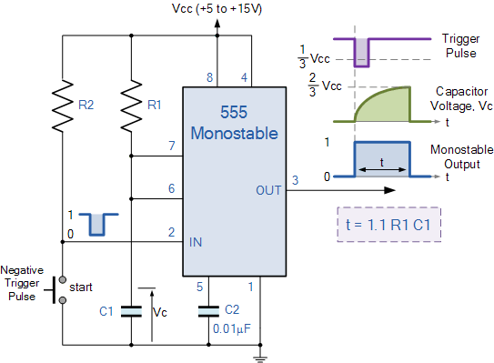

When a negative ( 0V ) pulse is applied to the trigger input (pin 2) of the Monostable configured 555 Timer oscillator, the internal comparator, (comparator No1) detects this input and “sets” the state of the flip-flop, changing the output from a “LOW” state to a “HIGH” state. This action in turn turns “OFF” the discharge transistor connected to pin 7, thereby removing the short circuit across the external timing capacitor, C1.

This action allows the timing capacitor to start to charge up through resistor, R1 until the voltage across the capacitor reaches the threshold (pin 6) voltage of 2/3Vcc set up by the internal voltage divider network. At this point the comparators output goes “HIGH” and “resets” the flip-flop back to its original state which in turn turns “ON” the transistor and discharges the capacitor to ground through pin 7. This causes the output to change its state back to the original stable “LOW” value awaiting another trigger pulse to start the timing process over again. Then as before, the Monostable Multivibrator has only “ONE” stable state.

The **Monostable 555 Timer** circuit triggers on a negative-going pulse applied to pin 2 and this trigger pulse must be much shorter than the output pulse width allowing time for the timing capacitor to charge and then discharge fully. Once triggered, the 555 Monostable will remain in this “HIGH” unstable output state until the time period set up by the R1 x C1 network has elapsed. The amount of time that the output voltage remains “HIGH” or at a logic “1” level, is given by the following time constant equation.

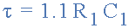

Where, t is in seconds, R is in Ω and C in Farads.

## 555 Timer Example No1

A **Monostable 555 Timer** is required to produce a time delay within a circuit. If a 10uF timing capacitor is used, calculate the value of the resistor required to produce a minimum output time delay of 500ms.

500ms is the same as saying 0.5s so by rearranging the formula above, we get the calculated value for the resistor, R as:

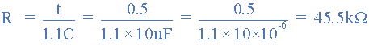

The calculated value for the timing resistor required to produce the required time constant of 500ms is therefore, 45.5KΩ. However, the resistor value of 45.5KΩ does not exist as a standard value resistor, so we would need to select the nearest preferred value resistor of 47kΩ which is available in all the standard ranges of tolerance from the E12 (10%) to the E96 (1%), giving us a new recalculated time delay of 517ms.

If this time difference of 17ms (500 – 517ms) is unacceptable instead of one single timing resistor, two different value resistor could be connected together in series to adjust the pulse width to the exact desired value, or a different timing capacitor value chosen.

We now know that the time delay or output pulse width of a monostable 555 timer is determined by the time constant of the connected RC network. If long time delays are required in the 10’s of seconds, it is not always advisable to use high value timing capacitors as they can be physically large, expensive and have large value tolerances, e.g, ±20%.

One alternative solution is to use a small value timing capacitor and a much larger value resistor up to about 20MΩ’s to produce the require time delay. Also by using one smaller value timing capacitor and different resistor values connected to it through a multi-position rotary switch, we can produce a Monostable 555 timer oscillator circuit that can produce different pulse widths at each switch rotation such as the switchable Monostable 555 timer circuit shown below.

### A Switchable Monostable Circuit

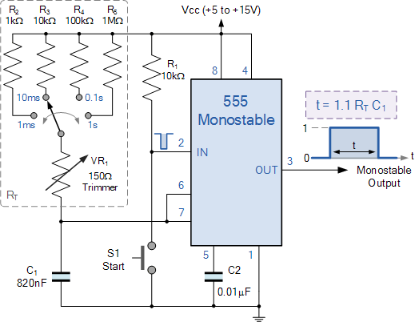

We can manually calculate the values of R and C for the individual components required as we did in the example above. However, the choice of components needed to obtain the desired time delay requires us to calculate with either kilohm’s (KΩ), Megaohm’s (MΩ), microfarad’s (μF) or picafarad’s (pF) and it is very easy to end up with a time delay that is out by a factor of ten or even a hundred.

We can make our life a little easier by using a type of chart called a “Nomograph” that will help us to find the monostable multivibrators expected frequency output for different combinations or values of both the R and C. For example,

### Monostable Nomograph

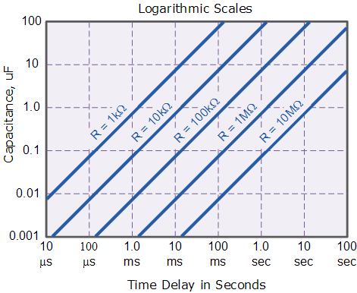

So by selecting suitable values of C and R in the ranges of 0.001uF to 100uF and 1kΩ to 10MΩ respectively, we can read the expected output frequency directly from the nomograph graph thereby eliminating any error in the calculations. In practice the value of the timing resistor for a monostable 555 timer should not be less than 1kΩ or greater than 20MΩ.

## Bistable 555 Timer

As well as the one shot **555 Monostable** configuration above, we can also produce a Bistable (two stable states) device with the operation and output of the **555 Bistable** being similar to the transistorised one we look at previously in the Bistable Multivibrators tutorial.

The **555 Bistable** is one of the simplest circuits we can build using the 555 timer oscillator chip. This bistable configuration does not use any RC timing network to produce an output waveform so no equations are required to calculate the time period of the circuit. Consider the Bistable 555 Timer circuit below.

### Bistable Flip-flop Circuit

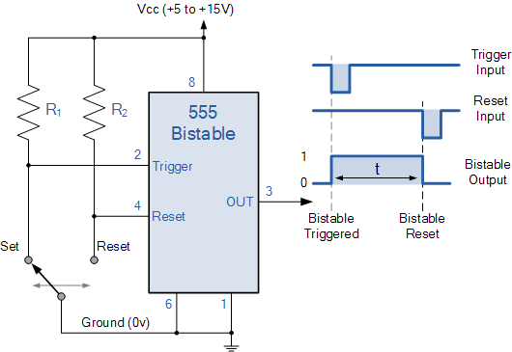

The switching of the output waveform is achieved by controlling the trigger and reset inputs of the 555 timer which are held “HIGH” by the two pull-up resistors, R1 and R2. By taking the trigger input (pin 2) “LOW”, switch in set position, changes the output state into the “HIGH” state and by taking the reset input (pin 4) “LOW”, switch in reset position, changes the output into the “LOW” state.

This 555 timer circuit will remain in either state indefinitely and is therefore bistable. Then the **Bistable 555 timer** is stable in both states, “HIGH” and “LOW”. The threshold input (pin 6) is connected to ground to ensure that it cannot reset the bistable circuit as it would in a normal timing application.

## 555 Timer Output

We could not finish this **555 Timer** tutorial without discussing something about the switching and drive capabilities of the 555 timer or indeed the dual **556 Timer IC**.

The output (pin 3) of the standard 555 timer or the 556 timer, has the ability to either “Sink” or “Source” a load current of up to a maximum of 200mA, which is sufficient to directly drive output transducers such as relays, filament lamps, LED’s motors, or speakers etc, with the aid of series resistors or diode protection.

This ability of the 555 timer to both “Sink” (absorb) and “Source” (supply) current means that the output device can be connected between the output terminal of the 555 timer and the supply to sink the load current or between the output terminal and ground to source the load current. For example.

### Sinking and Sourcing the 555 Timer Output

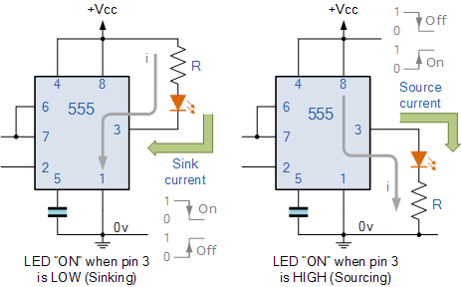

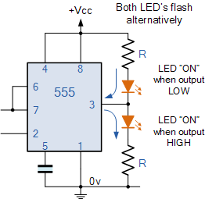

In the first circuit above, the LED is connected between the positive supply rail ( +Vcc ) and the output pin 3. This means that the current will “Sink” (absorb) or flow into the 555 timer output terminal and the LED will be “ON” when the output is “LOW”.

The second circuit above shows that the LED is connected between the output pin 3 and ground ( 0v ). This means that the current will “Source” (supply) or flow out of the 555 timers output terminal and the LED will be “ON” when the output is “HIGH”.

The ability of the 555 timer to both sink and source its output load current means that both LED’s can be connected to the output terminal at the same time but only one will be switched “ON” depending whether the output state is “HIGH” or “LOW”. The circuit to the left shows an example of this. the two LED’s will be alternatively switched “ON” and “OFF” depending upon the output. Resistor, R is used to limit the LED current to below 20mA.

We said earlier that the maximum output current to either sink or source the load current via pin 3 is about 200mA at the maximum supply voltage, and this value is more than enough to drive or switch other logic IC’s, LED’s or small lamps, etc. But what if we wanted to switch or control higher power devices such as motors, electromagnets, relays or loudspeakers. Then we would need to use a Transistor to amplify the 555 timers output in order to provide a sufficiently high enough power to drive the load.

### 555 Timer Transistor Driver

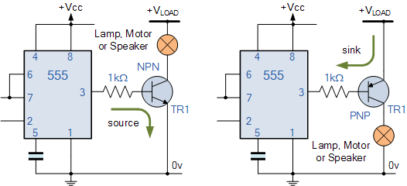

The transistor in the two examples above, can be replaced with a Power MOSFET device or Darlington transistor if the load current is high. When using an inductive load such as a motor, relay or electromagnet, it is advisable to connect a freewheeling (or flywheel) diode directly across the load terminals to absorb any back emf voltages generated by the inductive device when it changes state.

Thus far we have look at using the **555 Timer** to generate monostable and bistable output pulses. In the next tutorial about Waveform Generation we will look at connecting the 555 in an astable multivibrator configuration. When used in the astable mode both the frequency and duty cycle of the output waveform can be accurately controlled to produce a very versatile waveform generator.

# **Basic Electronics - Capacitors**

A Capacitor is a passive component that has the ability to store the energy in the form of potential difference between its plates. It resists a sudden change in voltage. The charge is stored in the form of potential difference between two plates, which form to be positive and negative depending upon the direction of charge storage.

A non-conducting region is present between these two plates which is called as **dielectric**. This dielectric can be vacuum, air, mica, paper, ceramic, aluminum etc. The name of the capacitor is given by the dielectric used.

## Symbol and Units

The standard units for capacitance is Farads. Generally, the values of capacitors available will be in the order of micro-farads, pico-farads and nano-farads. The symbol of a capacitor is as shown below.

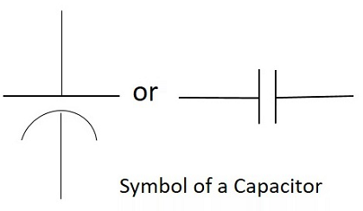

The Capacitance of a capacitor is proportional to the distance between the plates and is inversely proportional to the area of the plates. Also, the higher the permittivity of a material, the higher will be the capacitance. The **permittivity** of a medium describes how much electric flux is being generated per unit charge in that medium. The following image shows some practical capacitors.

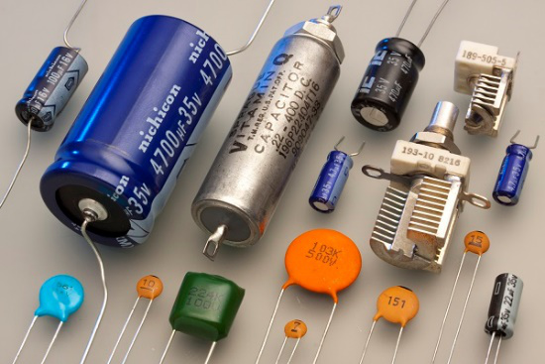

When two plates having same area A, and equal width are placed parallel to each other with a separation of distance d, and if some energy is applied to the plates, then the capacitance of that parallel plate capacitor can be termed as −

C=ε0εrdAC=ε0εrdA

Where

**C** = Capacitance of a capacitor

ε0ε0 = permittivity of free space

εrεr = permittivity of dielectric medium

**d** = distance between the plates

**A** = area of the two conducting plates

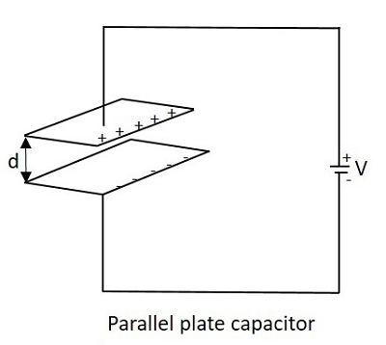

With some voltage applied, the charge deposits on the two parallel plates of the capacitor. This charge deposition occurs slowly and when the voltage across the capacitor equals the voltage applied, the charging stops, as the voltage entering equals the voltage leaving.

The rate of charging depends upon the value of capacitance. The greater the value of capacitance, the slower the rate of change of voltage in the plates.

## Working of a Capacitor

A Capacitor can be understood as a two-terminal passive component which stores electrical energy. This electrical energy is stored in electrostatic field.

Initially, the negative and positive charges on two plates of the capacitor are in equilibrium. There is no tendency for a capacitor to get charged or discharged. The negative charge is formed by the accumulation of electrons, while the positive charge is formed by the depletion of electrons. As this happens without any external charge given, this state is **electrostatic** condition. The figure below shows the capacitor with static charges.

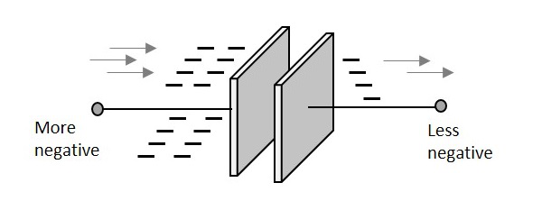

The accumulation and depletion of electrons according to the varying positive and negative cycles of the AC supply, can be understood as “current flow”. This is called as **Displacement Current**. The direction of this current flow keeps on changing as this is AC.

### **Charging of a Capacitor**

When an external voltage is given, the electric charge gets converted into electrostatic charge. This happens while the capacitor is charging. The positive potential of the supply, attracts the electrons from the positive plate of the capacitor, making it more positive. While the negative potential of the supply, forces the electrons to the negative plate of the capacitor, making it more negative. The figure below explains this.

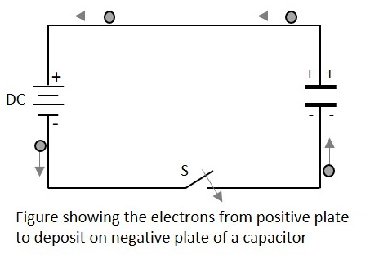

During this process of charging, the electrons move through the DC supply but not through the **dielectric** which is an **insulator**. This displacement is large, when the capacitor starts to charge but reduces as it charges. The capacitor stops charging when the voltage across capacitor equals the supply voltage.

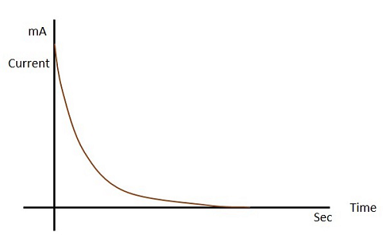

Let us see what happens to the dielectric when the capacitor begins to charge.

### **Dielectric behavior**

As the charges deposit on the plates of the capacitor, an electrostatic field is formed. The strength of this electrostatic field depends upon the magnitude of charge on the plate and the permittivity of the dielectric material. **Permittivity** is the measure of dielectric whether how far it allows the electrostatic lines to pass through it.

The dielectric is actually an insulator. It has electrons in the outer most orbit of the atoms. Let us observe how they get affected. When there is no charge on the plates, the electrons in the dielectric move in circular orbit. This is as shown in the figure below.

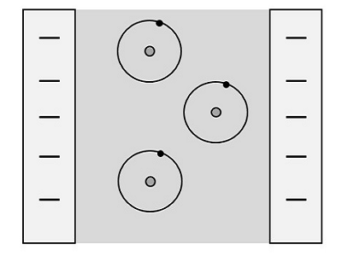

When charge deposition takes place, the electrons tend to move towards the positive charged plate, but still they keep on revolving as shown in the figure.

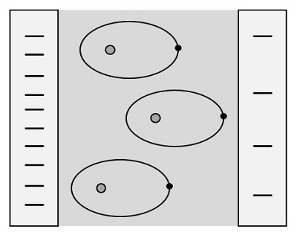

If the charge increases further, the orbits expand more. But if it still increases, the dielectric **breaks down** shorting the capacitor. Now, the capacitor being fully charged, it’s ready to get discharged. It is enough if we provide a path for them to travel from negative to positive plate. The electrons flow without any external supply as there are too many number of electrons on one side and barely any electrons on the other. This imbalance is adjusted by the **discharge** of the capacitor.

Also, when a discharge path is found, the atoms in the dielectric material tend to get to their normal **circular orbit** and hence forces the electrons to get discharged. This kind of discharge enables capacitors to deliver high currents in a short period of time, just as in a camera flash.

## Color Coding

To know the value of a capacitor, it is usually labelled as below −

n35 = 0.35nF or 3n5 = 3.5nF or 35n = 35nF and so on.

Sometimes the markings will be like 100K which means, k = 1000pF. Then the value will be 100 × 1000pF = 100nF.

Though these number markings are being used now-a-days, an International color coding scheme was developed long ago, to understand the values of capacitors. The color coding indications are just as given below.

|  |  |  |  |  |  |
| --- | --- | --- | --- | --- | --- |
| **Band colour** | **Digit A and B** | **Multiplier** | **Tolerance**tt**> 10pf** | **Tolerance**tt**< 10pf** | **Temperature coefficient** |
| Black | 0 | × 1 | ±20% | ±2.0pF |  |
| Brown | 1 | × 10 | ±1% | ±0.1pF | -33 × 10-6 |
| Red | 2 | × 100 | ±2% | ±0.25pF | -75 × 10-6 |
| Orange | 3 | × 1,000 | ±3% |  | -150 × 10-6 |
| Yellow | 4 | × 10,000 | ±4% |  | -220 × 10-6 |
| Green | 5 | × 100,000 | ±5% | ±0.5pF | -330 × 10-6 |
| Blue | 6 | × 1,000000 |  |  | -470 × 10-6 |
| Violet | 7 |  |  |  | -750 × 10-6 |
| Gray | 8 | × 0.01 | +80%, -20% |  |  |
| White | 9 | × 0.1 | ±10% | ±1.0pF |  |
| Gold |  | × 0.1 | ±5% |  |  |
| Silver |  | × 0.01 | ±10% |  |  |

These indications were used to identify the value of capacitors.

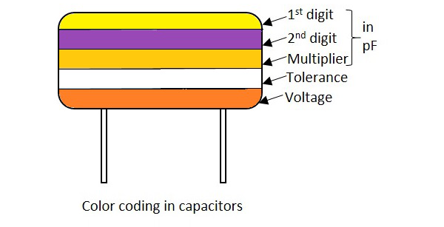

In these five band capacitors, the first two bands represent digits, third one indicates multiplier, fourth for tolerance and the fifth represents voltage. Let us look at an example to understand the color coding process.

**Example 1** − Determine the value of a capacitor with a color code yellow, violet, orange, white and red.

**Solution** − The value of yellow is 4, violet is 7, orange is 3 which represents multiplier. White is ±10 which is the tolerance value. Red represents the voltage. But to know the voltage rating, we have got another table, from which the particular band to which this capacitor belongs, has to be known.

Hence the value of the capacitor is 47nF, 10% 250v voltageforVbandvoltageforVband

The following table shows how voltage is determined depending upon the bands the capacitors belong to.

|  |  |  |  |  |  |
| --- | --- | --- | --- | --- | --- |
| **Band colour** | **Voltage Rating**VV | | | | |
|  | **TYPE J** | **TYPE K** | **TYPE L** | **TYPE M** | **TYPE N** |
| Black | 4 | 100 |  | 10 | 10 |
| Brown | 6 | 200 | 100 | 1.6 |  |
| Red | 10 | 300 | 250 | 4 | 35 |
| Orange | 15 | 400 |  | 40 |  |
| Yellow | 20 | 500 | 400 | 6.3 | 6 |
| Green | 25 | 600 |  | 16 | 15 |
| Blue | 35 | 700 | 630 |  | 20 |
| Violet | 50 | 800 |  |  |  |
| Gray |  | 900 |  | 25 | 25 |
| White | 3 | 1000 |  | 2.5 | 3 |
| Gold |  | 2000 |  |  |  |
| Silver |  |  |  |  |  |

With the help of this table, the voltage rating for each band of capacitors is known according to the color given. The type of voltage ratings also indicates the type of capacitors. For example, TYPE J ones are Dipped Tantalum Capacitors, TYPE K ones are Mica Capacitors, TYPE L ones are Polystyrene Capacitors, TYPE M ones are Electrolytic Band 4 Capacitors and TYPE N ones are Electrolytic Band 3 Capacitors. These days, the color coding has been replaced by simple printing of value of the capacitors as mentioned previously.

## Capacitive Reactance

This is an important term. Capacitive Reactance is the opposition offered by a capacitor to the alternating current flow, or simply AC current. A capacitor resists the change in the flow of current and hence it shows some opposition which can be termed as **reactance**, as the frequency of the input current should also be considered along with the resistance it offers.

**Symbol: XC**

In a purely capacitive circuit, the current **IC leads** the applied voltage by 90°

## Temperature Coefficient of Capacitors

The maximum change in **Capacitance** of a capacitor, over a specified temperature range, can be known by the temperature coefficient of a capacitor. It states that when the temperature exceeds a certain point, the change in capacitance of a capacitor that might occur is understood as the **temperature coefficient of capacitors**.

All the capacitors are usually manufactured considering a reference temperature of 25°C. Hence the temperature coefficient of capacitors is considered for the values of temperatures that are above and below this value.

# **Circuit Connections in Capacitors**

In a circuit, a Capacitor can be connected in series or in parallel fashion. If a set of capacitors were connected in a circuit, the type of capacitor connection deals with the voltage and current values in that network.

## Capacitors in Series

Let us observe what happens, when few Capacitors are connected in Series. Let us consider three capacitors with different values, as shown in the figure below.

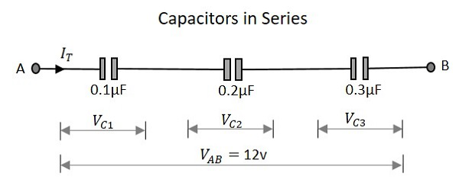

### **Capacitance**

When the capacitance of a network whose capacitors are in series is considered, the reciprocal of the capacitances of all capacitors, is added to get the reciprocal of the total capacitance. To get this more clearly,

1CT=1C1+1C2+1C31CT=1C1+1C2+1C3

Following the same formula, if simply two capacitors are connected in series, then

CT=C1×C2C1+C2CT=C1×C2C1+C2

Where C1 is the capacitance across the 1st capacitor, C2 is the capacitance across the 2nd capacitor and C3 is the capacitance across the 3rd capacitor in the above network.

### **Voltage**

The voltage across each capacitor depends upon the value of individual capacitances. Which means

VC1=QTC1VC2=QTC2VC3=QTC3VC1=QTC1VC2=QTC2VC3=QTC3

The total voltage across the series capacitors circuit,

VT=VC1+VC2+VC3VT=VC1+VC2+VC3

Where Vc1 is the voltage across the 1st capacitor, Vc2 is the voltage across the 2nd capacitor and Vc3 is the voltage across the 3rd capacitor in the above network.

### **Current**

The total amount of Current that flows through a set of Capacitors connected in series is the same at all the points. Therefore the capacitors will store the same amount of charge regardless of their capacitance value.

Current through the network,

I=I1=I2=I3I=I1=I2=I3

Where I1 is the current through the 1st capacitor, I2 is the current through the 2nd capacitor and I3 is the current through the 3rd capacitor in the above network.

As the current is same, the storage of charge is same because any plate of a capacitor gets its charge from the adjacent capacitor and hence capacitors in series will have the same charge.

QT=Q1=Q2=Q3QT=Q1=Q2=Q3

## Capacitors in Parallel

Let us observe what happens, when few capacitors are connected in Parallel. Let us consider three capacitors with different values, as shown in the figure below.

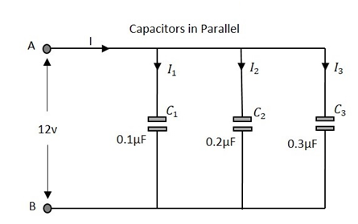

### **Capacitance**

The total Capacitance of the circuit is the equivalent to the sum of the individual capacitances of the capacitors in the network.

CT=C1+C2+C3CT=C1+C2+C3

Where C1 is the capacitance across the 1st capacitor, C2 is the capacitance across the 2nd capacitor and C3 is the capacitance across the 3rd capacitor in the above network.

### **Voltage**

The voltage measured at the end of the circuit is **same** as the voltage across all the capacitors that are connected in a parallel circuit.

VT=V1=V2=V3VT=V1=V2=V3

Where Vc1 is the voltage across the 1st capacitor, Vc2 is the voltage across the 2nd capacitor and Vc3 is the voltage across the 3rd capacitor in the above network.

### **Current**

The total current flowing is equal to the sum of the currents flowing through each capacitor connected in the parallel network.

IT=I1+I2+I3IT=I1+I2+I3

Where I1 is the current through the 1st capacitor, I2 is the current through the 2nd capacitor and I3 is the current through the 3rd capacitor in the above network.

# **Basic Electronics - Variable Capacitors**

There are many types of capacitors depending upon their function, the dielectric material used, their shape etc. The main classification is done according to fixed and variable capacitors.

## Types of Capacitors

The classification is as shown in the following figure.

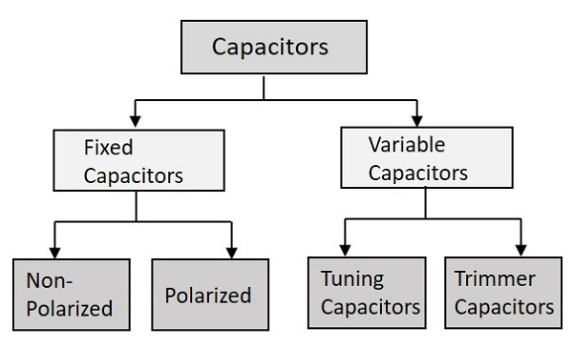

The main classification is just like the above one. The fixed capacitors are the ones whose value is fixed at the time of manufacturing itself and the variable ones provide us with an option to vary the value of capacitance.

## Variable Capacitors

Let us know something about the variable capacitors whose value alters when you vary, either **electrically** or **mechanically**. Variable capacitors in general consists of interwoven sets of metallic plates in which one is fixed and the other is variable. These capacitors provide the capacitance values so as to vary between **10 to 500pF**.

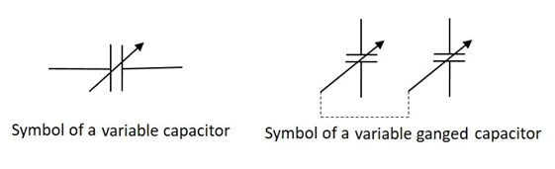

The ganged capacitor shown here is a combination of two capacitors connected together. A single shaft is used to rotate the variable ends of these capacitors which are combined as one. The dotted line indicates that they are connected internally.

There are many uses of these variable resistors such as for tuning in LC circuits of radio receivers, for impedance matching in antennas etc. The main types of variable capacitors are Tuning capacitors and Trimmer capacitors.

### **Tuning Capacitors**

Tuning capacitors are popular type of variable capacitors. They contain a stator, a rotor, a frame to support the stator and a mica capacitor. The constructional details of a tuning capacitor are shown in the following figure.

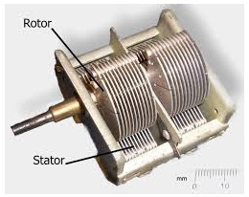

The stator is a stationary part and rotor rotates by the movement of a movable shaft. The rotor plates when moved into the slots of stator, they come close to form plates of a capacitor. When the rotor plates sit completely in the slots of the stator then the capacitance value is maximum and when they don’t, the capacitance value is minimum.

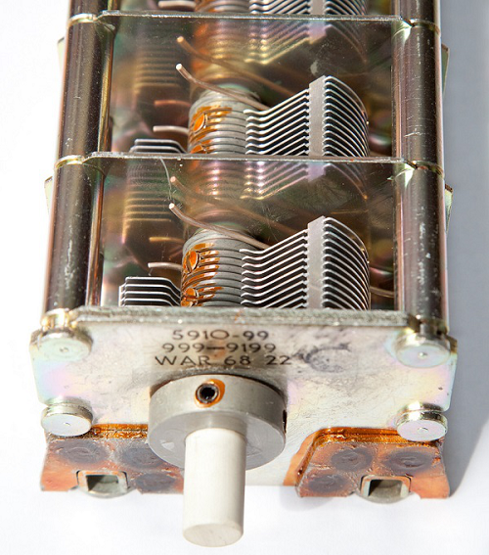

The above figure shows a **ganged tuning capacitor** having two tuning capacitors connected in a gang. This is how a tuning capacitor works. These capacitors generally have capacitance values from few Pico Farads to few tens of Pico Farads. These are mostly used in LC circuits in radio receivers. These are also called as **Tuning Condensers**.

### **Trimmer Capacitors**

Trimmer capacitors are varied using a screwdriver. Trimmer capacitors are usually fixed in such a place where there is no need to change the value of capacitance, once fixed.

There are three leads of a trimmer capacitor, one connected to stationary plate, one to rotary and the other one is common. The movable disc is a semi-circular shaped one. A trimmer capacitor would look like the ones in the following figure.

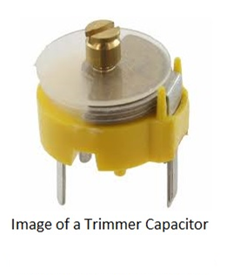

There are two parallel conducting plates present with a dielectric in the middle. Depending upon this dielectric used, there are air trimmer capacitors and ceramic trimmer capacitors. The constructional details of a trimmer capacitor are as shown below.

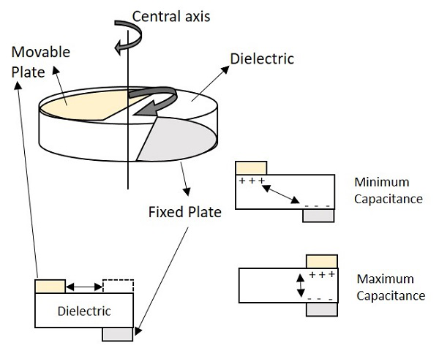

One of the two plates is movable, while the other is fixed. The dielectric material is fixed. When the movable plate is moved, opposite to the area between movable and fixed electrode, then the capacitance can be changed. The capacitance will be higher if the opposite area gets bigger, as both the electrodes act as two plates of a capacitor.

The Trimmer Capacitors are easily fixed on a PCB PrintedCircuitBoardPrintedCircuitBoard and they are mostly used for calibration of equipment.

# **Basic Electronics - Fixed Capacitors**

The Capacitors whose value is fixed while manufacturing and cannot be altered later are called as **Fixed Capacitors**. The main classification of fixed capacitors is done as polarized and non-polarized. Let us have a look at Non-polarized capacitors.

## Non-Polarized Capacitors

These are the capacitors that have **no specific polarities**, which means that they can be connected in a circuit, either way without bothering about the placement of right lead and left lead. These capacitors are also called as **Non-Electrolytic Capacitors**.

The main classification of Non-Polarized capacitors is done as shown in the following figure.

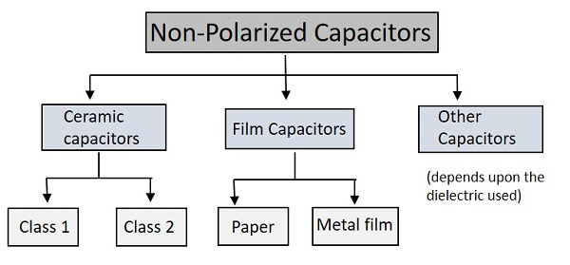

Among the types of capacitors, let us first go through the Ceramic Capacitors.

## Ceramic Capacitors

The common capacitors used among fixed type are Ceramic Capacitors. The Ceramic capacitors are fixed capacitors that have **ceramic material** as a dielectric.

These ceramic capacitors are further classified as class1 and class2 depending upon their applications. For instance, **Class1** has high stability and works best for resonant circuit applications, while **class2** has high efficiency and gives its best for coupling applications.

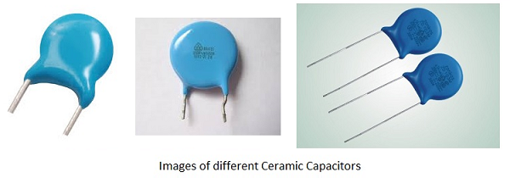

A hollow tubular or plate like ceramic material such as **titanium dioxide** and **barium titanate** is coated with a deposition of silver compound on both walls, so that both sides act as two capacitor plates and ceramic acts as a dielectric. Leads are drawn from these two surfaces and this whole assembly is encapsulated in a moisture-proof coating.

The most often used modern ceramic capacitors are **Multi-Layer Chip Capacitors** (**MLCC**). These capacitors are made in surface mounted technology and are mostly used due to their small size. These are available in the order of 1ηF to 100µF.

## Film Capacitors

The Film Capacitors are the ones which have a film substance as a dielectric material. Depending upon the type of film used, these are classified as **Paper** and **Metal film** capacitors.

These film capacitors are both paper dielectric capacitors whereas a paper capacitor uses a **waxed** paper while a metallic film capacitor uses a **metallized** paper. The arrangement is almost same as shown below.

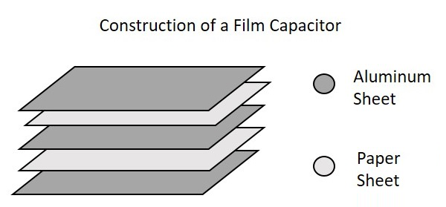

### **Paper Capacitors**

Paper capacitors use Paper as a dielectric material. Two thin tin foil sheets are taken and placed between thin waxed or oiled paper sheets. This paper acts as a dielectric. Now-a-days paper is being replaced by plastic.

These sheets are sandwiched and are rolled into a cylindrical shape and encapsulated in a plastic enclosure. Leads are drawn out. The following figure shows an example of Paper Capacitors.

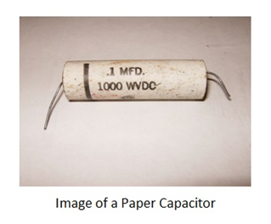

Paper capacitors are available in the order of 0.001µF to 2µF and the voltage rating can be as high as 2000volts. These capacitors are useful in high voltage and current applications.

### **Metal Film Capacitors**

Metal Film capacitors are another type of film capacitors. These are also called as Metal Foil Capacitors or Metallized Paper Capacitors as the dielectric used here is a paper coated with metallic film.

Unlike in paper capacitors, a film of Aluminum or Zinc is coated on a paper to form a dielectric in this metallic film capacitors. Instead of Aluminum sheets placing between papers, the paper itself is directly coated here. This reduces the size of the capacitor.

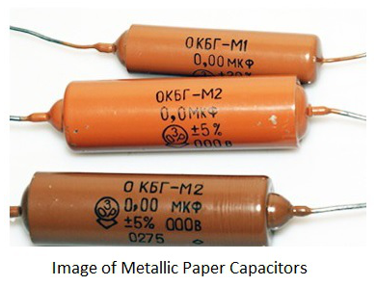

The Aluminum coating is preferred over zinc coating so as **to avoid destruction** of capacitor due to chemical reduction. The Aluminum coated sheets are rolled in the form of a cylinder and leads are taken. This whole thing is encapsulated with wax or plastic resin to protect the capacitor. These capacitors are useful in **high voltage and current** applications.

## Other Capacitors

These are the miscellaneous capacitors that are named after the dielectric materials used. This group includes Mica Capacitors, Air Capacitors, Vacuum Capacitors and Glass Capacitors etc.

### **Mica Capacitors**

The Mica Capacitors are made by using thin Mica sheets as dielectric materials. Just like paper capacitors, thin metal sheets are sandwiched with mica sheets in between. Finally the layers of metal sheets are connected at both ends and two leads are formed. Then the whole assembly is enclosed in plastic Bakelite capsule. The following image shows how a Mica capacitor looks like.

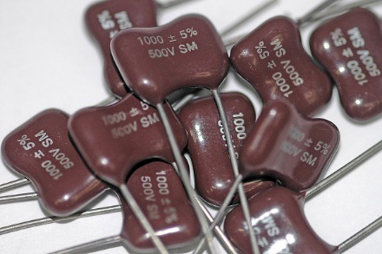

Mica Capacitors are available in the range of 50pF to 500pF. The Mica capacitors have high working voltage up to 500volts. These are most commonly used capacitors for electronic circuits such as ripple filters, Resonant circuits, Coupling circuits and high power, high current RF broadcast transmitters.

### **Air Capacitors**

The Air Capacitors are the ones with **air as dielectric**. The simplest air capacitors are the ones with conducting plates having air in between. This construction is exactly the same as the **variable tuning capacitor** discussed above. These capacitors can be fixed and variable also but fixed are very rarely used as there are others with superior characteristics.

### **Vacuum Capacitors**

The Vacuum Capacitors uses **high vacuum as dielectric** instead of air or some other material. These are also available in fixed and variable modes. The construction of these capacitors is similar to vacuum tubes. They are mostly seen in the form of a glass cylinder which contain inter-meshed concentric cylinders.

The following image shows a variable vacuum capacitor.

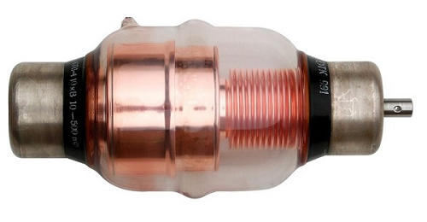

The following image shows how a fixed vacuum capacitor looks like −

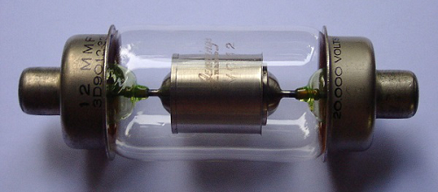

Variable vacuum capacitors are available at a range of 12pF to 5000pF and they are used for high voltage applications such as 5kV to 60kV. They are used in main equipment such as **high power broadcast transmitters, RF amplifiers** and large **antenna tuners**.

### **Glass Capacitors**

Glass capacitors are very exclusive ones with many advantages and applications. As all of the above types, here **glass** is the dielectric substance. Along with glass dielectric, Aluminum electrodes are also present in these capacitors. Plastic encapsulation is done after taking out the leads. The leads can be axial leads or tubular leads.

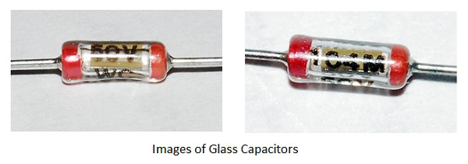

There are many advantages of a glass capacitor such as −

* The temperature coefficient is low.
* These are Noise-free capacitors.
* They produce high quality output with low loss.
* They have the capability of handling high operating temperatures.
* These capacitors can handle large RF currents.

There are many applications for these glass capacitors such as −

* Used in circuits that need to be at high temperature zones.
* Used in circuits that need high Q.
* Used in high power handling circuits.
* Used for circuits that need high tolerances.

# **Basic Electronics - Polarized Capacitors**

Polarized Capacitors are the ones that have specific positive and negative polarities. While using these capacitors in circuits, it should always be taken care that they are connected in **perfect polarities**. The following image shows the classification of polarized capacitors.

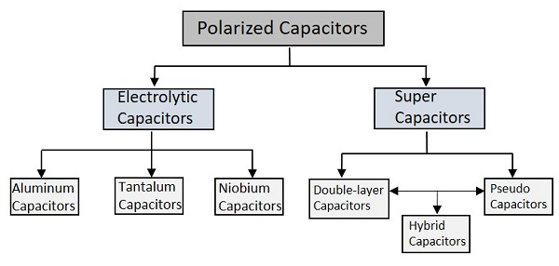

Let’s start the discussion with Electrolytic Capacitors.

## Electrolytic Capacitors

The Electrolytic Capacitors are the capacitors which indicate by the name that some electrolyte is used in it. They are polarized capacitors which have anode ++ and cathode −− with particular polarities.

A metal on which **insulating oxide layer** forms by anodizing is called as an **Anode**. A solid or non-solid **electrolyte** which covers the surface of the oxide layer, functions as a **cathode**. The Electrolytic Capacitors have much higher **Capacitance-Voltage**CVCV**value** than the others, due to their larger anode surface and thin dielectric oxide layer.

### **Aluminum Electrolytic Capacitors**

Aluminum Electrolytic Capacitors are the most common types among the Electrolytic capacitors. In these ones, a pure **Aluminum foil** with an etched surface acts as an **Anode**. A thin layer of metal, which has a thickness of few micrometers acts as a **diffusion barrier**, which is placed between two metals to separate electrically. Hence the diffusion barrier acts as a **dielectric**. The **electrolyte** acts as a **cathode** which covers the rough surface of oxide layer.

The following figure shows an image of different sizes of Aluminum Electrolytic Capacitors available.

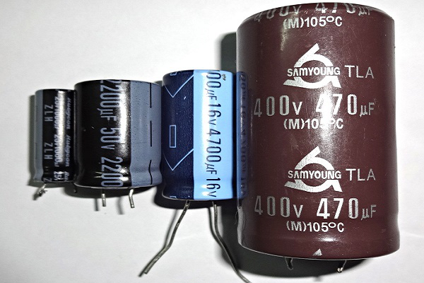

Depending upon the electrolyte there are three types of Aluminum Electrolytic Capacitors. They are −

* Wet Aluminum Electrolytic capacitors non−solidnon−solid
* Manganese dioxide Aluminum Electrolytic capacitors solidsolid
* Polymer Aluminum Electrolytic capacitors solidsolid

The main advantage with these Aluminum Electrolytic capacitors is that, they have **low impedance** values even at mains frequency and they are cheaper. These are mostly used in **Power supply circuits, SMPS** SwitchedModePowerSupplySwitchedModePowerSupply and **DC-DC Converters**.

### **Tantalum Electrolytic capacitors**

These are another type of Electrolytic capacitors whose **anode** is made up of **tantalum** on which a very thin insulating **oxide layer** is formed. This layer acts as a **dielectric** and the **electrolyte** acts as a cathode which covers the surface of oxide layer.

The following figure shows how tantalum capacitors look like.

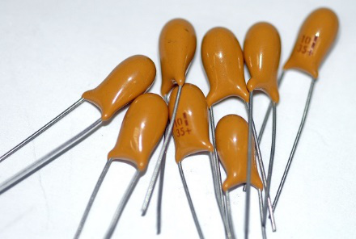

Tantalum provides high permittivity dielectric layer. Tantalum has high capacitance per volume and lower weight. But these ones are costlier than Aluminum Electrolytic capacitors, due to the frequent unavailability of tantalum.

### **Niobium Electrolytic Capacitors**

A Niobium Electrolytic Capacitor is the other type of Electrolytic Capacitors in which a passivated niobium metal or niobium monoxide is considered as anode and an insulating niobium pentoxide layer is added on to the anode, so that it acts as a dielectric. A solid electrolyte is laid on the surface of the oxide layer which acts as a cathode. The following figure shows how Niobium capacitors look like.

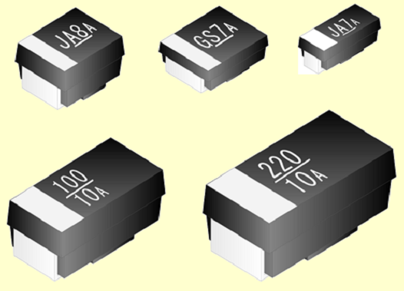

The Niobium Capacitors are commonly available as SMD SurfaceMountDevicesSurfaceMountDevices chip capacitors. These are easily fitted in a PCB. These capacitors should be operated in perfect polarities. Any kind of reverse voltage or ripple current higher than the specified will eventually **destroy the dielectric** and the capacitor as well.

## Super Capacitors

The high capacity electrochemical capacitors with capacitance values much higher than the other capacitors, are called as **Super Capacitors**. These can be categorized as a group that lies between electrolytic capacitors and rechargeable batteries. These are also called as **Ultra Capacitors**.

There are many advantages with these capacitors such as −

* They have high capacitance value.
* They can store and deliver charge much faster.
* They can handle more charge and discharge cycles.

These capacitors have many applications such as −

* They are used in cars, buses, trains, elevators and cranes.
* They are used in regenerative braking.
* They are used for memory backup.

The types of super capacitors are Double-layered, Pseudo and Hybrid ones.

### **Double-layered Capacitors**

Double-layered capacitors are electrostatic capacitors. The charge deposition is done in these capacitors according to the principle of Double-layer.

* All solid substances have negative charge on the surface layer when disposed into a liquid.
* This is due to the high dielectric coefficient of liquid.
* All the positive ions come near the surface of the solid material to make a skin.
* The deposition of positive ions near the solid material get looser with the distance.
* The charge created at this surface due to the deposition of anions and cations leads to some capacitance value.

This double-layer phenomenon is also termed as Helmholtz double layer. The figure below explains the procedure of double-layer phenomenon, when the capacitor is charged and when it is discharged.

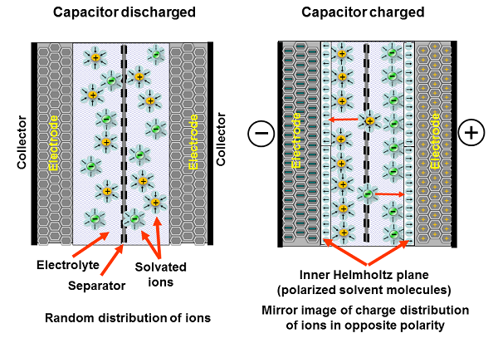

These capacitors are simply called as Electric Double Layered Capacitors EDLCEDLC. They use carbon electrodes to achieve separation of charge between the surface of conductive electrode and the electrolyte. The carbon acts as dielectric and the other two as anode and cathode. The separation of charge is much smaller than in a conventional capacitor.

### **Pseudo Capacitors**

These capacitors follow the **electrochemical** process for the deposition of charge. This is also called as **faradaic process**. At an electrode, when some chemical substance reduces or oxidizes, some current is generated. During such process, these capacitors store the electric charge by electron transfer between electrode and electrolyte. This is the working principle of Pseudo capacitors.

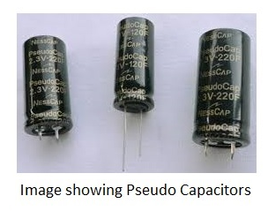

They get charged much faster and store the charge as much as a battery does. They are operated at a faster rate. These are used in tandem with batteries to improve life. These are used in grid applications to handle power fluctuations.

### **Hybrid Capacitors**

A Hybrid Capacitor is a combination of EDLC and Pseudo Capacitor. In the Hybrid capacitors, activated carbon is used as cathode and the pre-doped carbon material acts as anode. Li ion capacitor is the common example of this type. The following figure shows different types of Hybrid Capacitors.

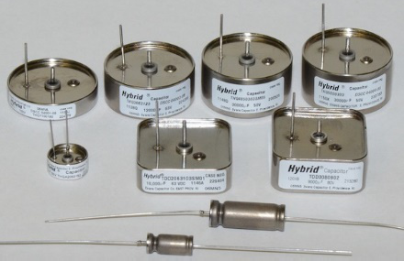

They have high tolerance in a wide range of temperature variations from -55°C to 200°C. Hybrid capacitors are also used in airborne applications. Though cost is high, these capacitors are highly reliable and compact. These are rugged and can tolerate extreme shock, vibration and pressure from environment. Hybrid capacitors have higher energy density and higher specific power than any electrolytic capacitor.

# **Basic Electronics - Inductors**

Let me introduce you to another important component in the field of Electronics and Electricals, the **Inductor**. Inductor is a passive two-terminal component that temporarily stores energy in the form of a magnetic field. It is usually called as a **coil**. The main property of an inductor is that it **opposes any change in current**.

## Inductor

According to the Faraday’s law of Electromagnetic induction, When the current flowing through an inductor changes, the time-varying magnetic field induces a voltage in the conductor. According to lens law, the direction of induced EMF opposes the change in current that created it. Hence, **induced EMF is opposite to the voltage** applied across the coil. This is the property of an inductor.

The following figure shows how an inductor looks like.

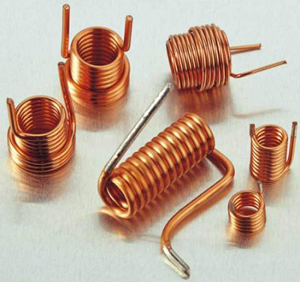

An inductor blocks any AC component present in a DC signal. The inductor is sometimes wrapped upon a core, for example a ferrite core. It then looks as in the figure below.

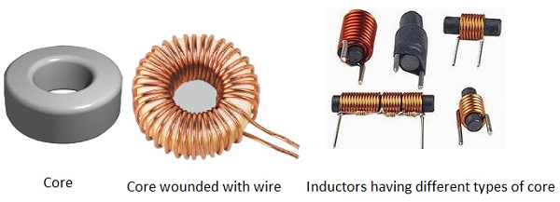

The following figure shows an inductor with various parts labelled.

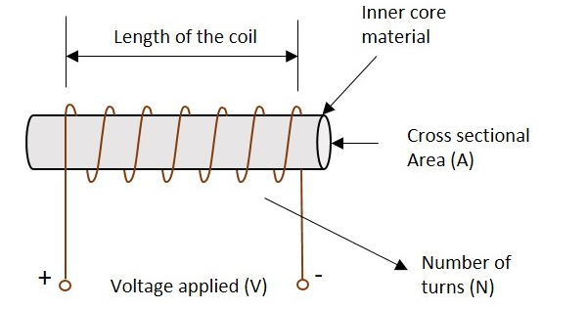

### **Symbols**

The symbols of various types of inductors are as given below.

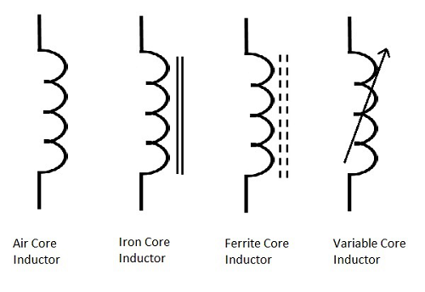

### **Storage of Energy**

One of the Basic properties of electromagnetism is that the current when flows through an inductor, a magnetic field gets created perpendicular to the current flow. This keeps on building up. It gets stabilized at some point, which means that the inductance won’t build up after that. When the current stops flowing, the magnetic field gets decreased.

This magnetic energy gets turned into electrical energy. Hence energy gets stored in this temporarily in the form of magnetic field.

## Working of an Inductor

According to the theory of Electromagnetic Induction, any varying electric current, flowing in a conductor, produces a magnetic field around that, which is perpendicular to the current. Also, any varying magnetic field, produces current in the conductor present in that field, whereas the current is perpendicular to the magnetic field.

Now, if we consider an inductor which is made up of a conducting coil and when some current passes through the inductor, a magnetic field is created perpendicular to it. The following figure indicates an inductor with magnetic field around it.

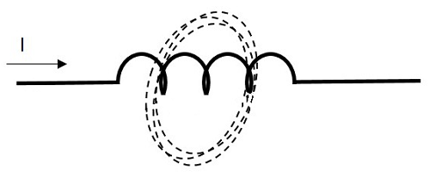

Now, here we have a varying magnetic field, which creates some current through the conductor. But this current is produced such that it opposes the main current, which has produced the magnetic field.

If this current is named as Im which means the current produced due to the magnetic field and the magnetic field is indicated by β, the following figure indicates it.

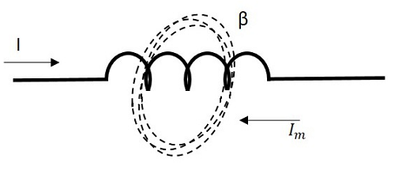

This opposing current gains strength with the varying magnetic field, which gains energy by the input supply frequency. Hence as the input current becomes more and more AC with high frequency, the resulting opposing current also gains its strength in opposite direction to the very cause producing it. Now, this opposing current, tries to stop the high frequency AC to pass through the inductor, which means “blocking of AC”.

# **Basic Electronics - Inductance**

The property of an inductor to get the voltage induced by the change of current flow, is defined as Inductance. Inductance is the ratio of voltage to the rate of change of current.

The rate of change of current produces change in the magnetic field, which induces an EMF in opposite direction to the voltage source. This property of induction of EMF is called as the **Inductance**.

The formula for inductance is

Inductance=volatgerateofchangeofcurrentInductance=volatgerateofchangeofcurrent

**Units −**

* The unit of Inductance is **Henry**. It is indicated by **L**.
* The inductors are mostly available in mH milliHenrymilliHenry and μH microHenrymicroHenry.

A coil is said to have an inductance of **one Henry** when an EMF of **one volt** is self-induced in the coil where the current flowing changed at a rate of **one ampere per second**.

### **Self-Inductance**

If a coil is considered in which some current flows, it has some magnetic field, perpendicular to the current flow. When this current keeps on varying, the magnetic field also changes and this changing magnetic field, induces an EMF, opposite to the source voltage. This opposing EMF produced is the **self-induced voltage** and this method is called as **self-inductance**.

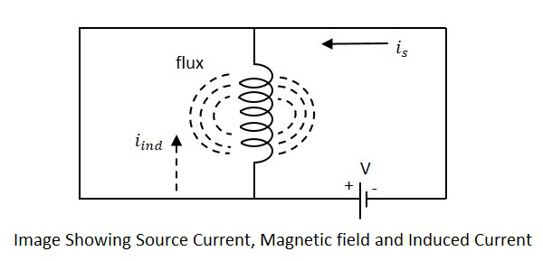

The current **is** in the figure indicate the source current while **iind** indicates the induced current. The flux represents the magnetic flux created around the coil. With the application of voltage, the current **is** flows and flux gets created. When the current **is** varies, the flux gets varied producing **iind**.

This induced EMF across the coil is proportional to the rate of change in current. The higher the rate of change in current the higher the value of EMF induced.

We can write the above equation as

EαdIdtEαdIdt

E=LdIdtE=LdIdt

Where,

* **E** is the EMF produced
* **dI/dt** indicates the rate of change of current
* **L** indicates the co-efficient of inductance.

Self-inductance or Co-efficient of Self-inductance can be termed as

L=EdIdtL=EdIdt

The actual equation is written as

E=−LdIdtE=−LdIdt

The minus in the above equation indicates that **the EMF is induced in opposite direction to the voltage source** according to Lenz’s law.

### **Mutual Inductance**

As the current carrying coil produces some magnetic field around it, if another coil is brought near this coil, such that it is in the magnetic flux region of the primary, then the varying magnetic flux induces an EMF in the second coil. If this first coil is called as **Primary coil**, the second one can be called as a **Secondary coil**.

When the EMF is induced in the secondary coil due to the varying magnetic field of the primary coil, then such phenomenon is called as the **Mutual Inductance**.

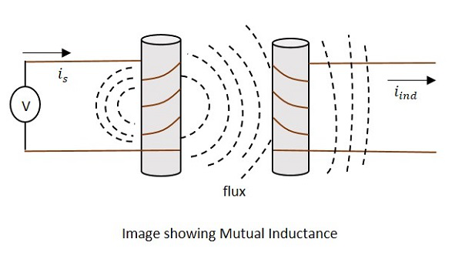

The current **is** in the figure indicate the source current while **iind** indicates the induced current. The flux represents the magnetic flux created around the coil. This spreads to the secondary coil also.

With the application of voltage, the current **is** flows and flux gets created. When the current **is** varies, the flux gets varied producing **iind** in the secondary coil, due to the Mutual inductance property.

The change took place like this.

VpIp→B→VsIsVpIp→B→VsIs

Where,

* ***Vp*** ***ip*** Indicate the Voltage and current in Primary coil respectively
* **B** Indicates Magnetic flux
* ***Vs*** ***is*** Indicate the Voltage and current in Secondary coil respectively

Mutual inductance **M** of the two circuits describes the amount of the voltage in the secondary induced by the changes in the current of the primary.

V(Secondary)=−MΔIΔtV(Secondary)=−MΔIΔt

Where ΔIΔtΔIΔt the rate of change of current with time and **M** is the co-efficient of Mutual inductance. The minus sign indicates the direction of current being opposite to the source.

**Units −**

The units of Mutual inductance is

volt=Mampssecvolt=Mampssec

FromtheaboveequationFromtheaboveequation

M=volt.secampM=volt.secamp

=Henry(H)=Henry(H)

Depending upon the number of turns of the primary and the secondary coils, the magnetic flux linkage and the amount of induced EMF varies. The number of turns in primary is denoted by N1 and secondary by N2. The co-efficient of coupling is the term that specifies the mutual inductance of the two coils.

## Factors affecting Inductance

There are a few factors that affect the performance of an inductor. The major ones are discussed below.

### **Length of the coil**

The length of the inductor coil is inversely proportional to the inductance of the coil. If the length of the coil is more, the inductance offered by that inductor gets less and vice versa.

### **Cross sectional area of the coil**

The cross sectional area of the coil is directly proportional to the inductance of the coil. The higher the area of the coil, the higher the inductance will be.

### **Number of turns**

With the number of turns, the coil affects the inductance directly. The value of inductance gets square to the number of turns the coil has. Hence the higher the number of turns, square of it will be the value of inductance of the coil.

### **Permeability of the core**

The **permeability**μμ of the core material of inductor indicates the support the core provides for the formation of a magnetic field within itself. The **higher** the permeability of the core material, the **higher** will be the inductance.

## Coefficient of Coupling

This is an important factor to be known for calculating Mutual inductance of two coils. Let us consider two nearby coils of N1 and N2 turns respectively.

The current through first coil i1 produces some flux Ψ1. The amount of magnetic flux linkages is understood by weber-turns.

Let the amount of magnetic flux linkage to the second coil, due to unit current of i1 be

N2φ1i1N2φ1i1

This can be understood as the Co-efficient of Mutual inductance, which means

M=N2φ1i1M=N2φ1i1

Hence the Co-efficient of Mutual inductance between two coils or circuits is understood as the weber-turns in one coil due to 1A of current in the other coil.

If the self-inductance of first coil is L1, then

L1i1=N1φ1=>L1N1φ1i1L1i1=N1φ1=>L1N1φ1i1

M=N2L1N1M=N2L1N1

Similarly, coefficient of mutual inductance due to current i2 in the second coil is

M=N1φ2i2⋯⋯⋯⋯1M=N1φ2i2⋯⋯⋯⋯1

If self-inductance of second coil is L2

L2i2=N2φ2L2i2=N2φ2

L2N2=φ2i2L2N2=φ2i2

Therefore,

M=N1L2N2⋯⋯⋯⋯2M=N1L2N2⋯⋯⋯⋯2

Multiplying 1 and 2, we get

M×M=N2L1N1×N1L2N2M×M=N2L1N1×N1L2N2

M2=L1L2=>M=L1L2−−−−√M2=L1L2=>M=L1L2

The above equation holds true when the whole changing flux of primary coil links with the secondary coil, which is an ideal case. But in practice, it is not the case. Hence, we can write as

M≠L1L2−−−−√M≠L1L2

andML1L2−−−−√=K≠1andML1L2=K≠1

Where K is known as the coefficient of coupling.

The **Coefficient of coupling K** can be defined as the ratio of actual coefficient of mutual inductance to the ideal maximummaximum coefficient of mutual inductance.

If the value of k is near to unity, then the coils are said to be tightly coupled and if the value of k = 0, then the coils are said to be loosely coupled.

## Applications of Inductors

There are many applications of Inductors, such as −

* Inductors are used in filter circuits to sense high-frequency components and suppress noise signals
* To isolate the circuit from unwanted HF signals.
* Inductors are used in electrical circuits to form a transformer and isolate the circuits from spikes.
* Inductors are also used in motors.

# **Circuit Connections in Inductors**

An Inductor when connected in a circuit, that connection can be either series or parallel. Let us now know what will happen to the total current, voltage and resistance values if they are connected in series as well, when connected in parallel.

## Inductors in Series

Let us observe what happens, when few inductors are connected in Series. Let us consider three resistors with different values, as shown in the figure below.

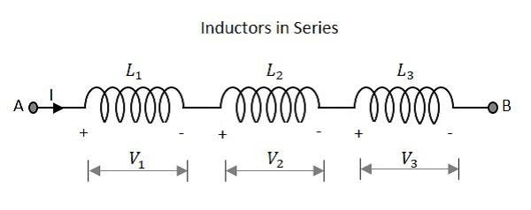

### **Inductance**

The total inductance of a circuit having series inductors is equal to the sum of the individual inductances. Total inductance value of the network given above is

LT=L1+L2+L3LT=L1+L2+L3

Where L1 is the inductance of 1st resistor, L2 is the inductance of 2nd resistor and L3 is the inductance of 3rd resistor in the above network.

### **Voltage**

The total voltage that appears across a series inductors network is the addition of voltage drops at each individual inductances.

Total voltage that appears across the circuit

V=V1+V2+V3V=V1+V2+V3

Where V1 is the voltage drop across 1st inductor, V2 is the voltage drop across 2nd inductor and V3 is the voltage drop across 3rd inductor in the above network.

### **Current**

The total amount of Current that flows through a set of inductors connected in series is the same at all the points throughout the network.

The Current through the network

I=I1=I2=I3I=I1=I2=I3

Where I1 is the current through the 1st inductor, I2 is the current through the 2nd inductor and I3 is the current through the 3rd inductor in the above network.

## Inductors in Parallel

Let us observe what happens, when few resistors are connected in Parallel. Let us consider three resistors with different values, as shown in the figure below.

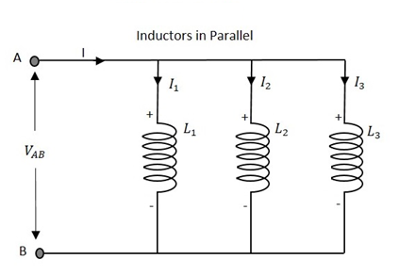

### **Inductance**

The total inductance of a circuit having Parallel resistors is calculated differently from the series inductor network method. Here, the reciprocal 1/R1/R value of individual inductances are added with the inverse of algebraic sum to get the total inductance value.

Total inductance value of the network is

1LT=1L1+1L2+1L31LT=1L1+1L2+1L3

Where L1 is the inductance of 1st inductor, L2 is the inductance of 2nd inductor and L3 is the inductance of 3rd inductor in the above network.

From the method we have for calculating parallel inductance, we can derive a simple equation for two-inductor parallel network. It is

LT=L1×L2L1+L2LT=L1×L2L1+L2

### **Voltage**

The total voltage that appears across a Parallel inductors network is same as the voltage drops at each individual inductances.

The Voltage that appears across the circuit

V=V1=V2=V3V=V1=V2=V3

Where V1 is the voltage drop across 1st inductor, V2 is the voltage drop across 2nd inductor and V3 is the voltage drop across 3rd inductor in the above network. Hence the voltage is same at all the points of a parallel inductor network.

### **Current**

The total amount of current entering a Parallel inductive network is the sum of all individual currents flowing in all the Parallel branches. The inductance value of each branch determines the value of current that flows through it.

The total Current through the network is

I=I1+I2+I3I=I1+I2+I3

Where I1 is the current through the 1st inductor, I2 is the current through the 2nd inductor and I3 is the current through the 3rd inductor in the above network.

Hence the sum of individual currents in different branches obtain the total current in a parallel network.

## Inductive Reactance

Inductive Reactance is the opposition offered by an inductor to the alternating current flow, or simply AC current. An inductor has the property of resisting the change in the flow of current and hence it shows some opposition which can be termed as **reactance**, as the frequency of the input current should also be considered along with the resistance it offers.

* Indication − **XL**
* Units − **Ohms**
* Symbol − **Ω**

In a purely inductive circuit, the current **IL lags** the applied voltage by 90°. Inductive reactance is calculated by,

XL=2πfLXL=2πfL

Where f is the frequency of the signal. Hence inductive reactance is a function of frequency and inductance.

# **Basic Electronics - Types of Inductors**

Inductors are available in different shapes and has different uses. Their sizes vary depending upon the material used to manufacture them. The main classification is done as fixed and variable inductors. An inductor of few Henries may be in a dumbbell shape at the size of a simple resistor. A fixed inductor always has silver as its first color in color coding.

The Core of the Inductor is its heart. There are many types of Inductors according to the core material used. Let us have a look at a few of them.

Air-core Inductor

The commonly seen inductor, with a simple winding is this air-Core Inductor. This has nothing but **air as the core** material. The non-magnetic materials like plastic and ceramic are also used as core materials and they also come under this air-core Inductors. The following image shows various air-core inductors.

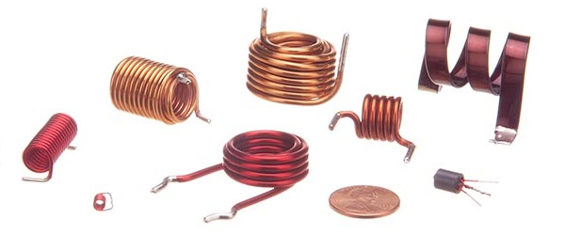

These Inductors offer a minimum signal loss at the applications having a very high magnetic field strength. Also, there exists no core losses as there is no solid core material.

Iron-Core Inductor

These Inductors have Ferromagnetic materials, such as ferrite or iron, as the core material. The usage of such core materials helps in the increase of inductance, due to their high magnetic permeability. **Permeability** measures the ability of supporting the formation of magnetic fields within the materials. The following image shows how an Iron-core Inductor looks like −

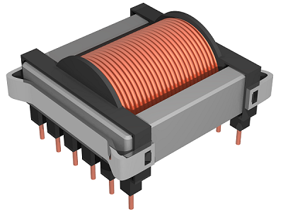

The inductors that have ferromagnetic core materials just like these, suffer from core losses and energy losses at high frequencies. These Inductors are used in the manufacture of few types of transformers.

Toroidal Inductors

These Inductors have a magnetic material as the core substance to which the wire is wound. These are in circular ring shape, just as shown in the following figure.

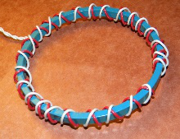

The main advantage of this type of inductors is that, due to the circular shape, symmetry is achieved in the whole shape of the inductor, due to which there are minimum losses in the magnetic flux. These inductors are mostly used in AC circuit applications.

Laminated Core Inductors

These are the inductors that have laminated thin steel sheets, such as stacks, as the core materials. Usually for an inductor, if the loop area is increased for the current to travel, the energy losses will be more. Whereas, in these laminated core Inductors, thin steel sheets of stacks are helpful in blocking the eddy currents, which minimize the loop action.

The following figure shows an image of a laminated core inductor.

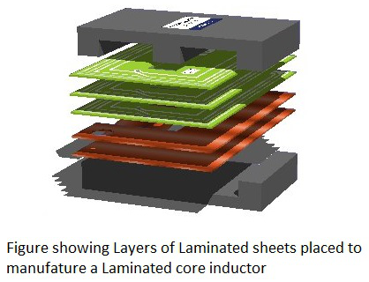

The main advantage of these inductors is minimizing the energy loss with its construction. These laminated core inductors are mostly used in the manufacture of transformers.

Powdered Iron Core Inductors

As the name implies, the core of these inductors have magnetic materials with some air gaps in it. But this kind of construction provides an advantage to the core, to store high level of energy compared with the other types. The following figure shows an image of a Powdered Iron core Inductor.

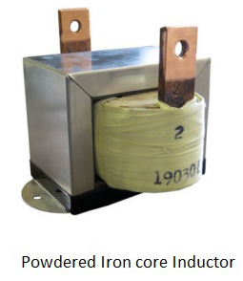

These inductors provide very low eddy current losses and hysteresis losses. These are available at lowest prices and have very good inductance stability.

# **Basic Electronics - RF Inductors**

RF inductors are the **radio frequency** inductors, which are used at **high resonant frequencies**. These can be multilayered coil inductor or a thin film coated ceramic inductor or some wire wound ceramic inductor. The following figure represents few RF inductors.

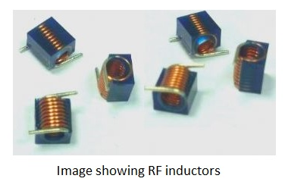

These inductors are characterized by **low current rating** and **high electrical resistance**. But as the high frequencies are used here, the wire resistance increases. Also, few effects come into picture because of these high resonant radio frequencies. Let us have a look at them.

### **Skin Effect**

At high frequencies, the alternating current has a tendency of unequal distribution of current through the conductor. The electric current flows highly at the surface of the conductor than at its center. It gets its energy concentrated in the **skin** of the conductor, leaving the deep core of the conductor, as shown in the following figure.

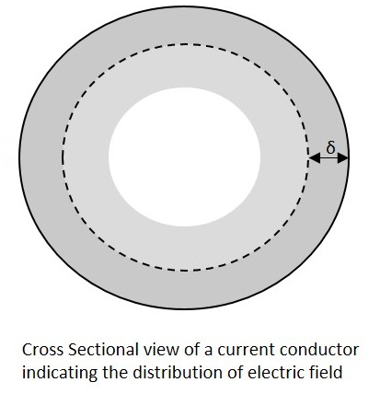

As the energy gets concentrated at the skin of the conductor, this effect is called as the **Skin Effect**. Actually this skin effect is caused due to the eddy currents which are produced by the changing Magnetic field, resulting from alternating current. Now-a-days, the conductors carrying higher frequencies are made in the form of tube shape, in order to reduce the weight and cost of the conductors.

### **Proximity Effect**

Along with the above one, this is another effect, which is observed here. Proximity effect is the one which increases the resistance of the wire at high frequencies. Proximity is the word which says that the effect will be on **adjacent wires**. The following figure shows the concentration of current on the edges of the adjacent cables.

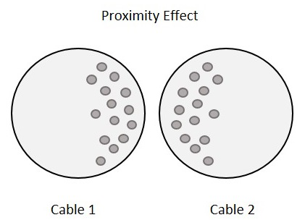

Each turn has some magnetic field which induces eddy currents in the wire that causes the current to be focused on the side of the adjacent wire. With this effect, the effective cross sectional area of the wire gets reduced and its **resistance gets increased**.

### **Parasitic Capacitance**

Usually, an inductor internally contains a resistor in series wireresistancewireresistance and a capacitor in shunt parasiticcapacitanceparasiticcapacitance. Each turn of winding has slightly different potential, in an inductor. The following figure shows the capacitance effect in an inductor.

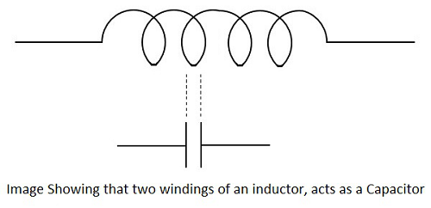

The two conductors that present in each turn, act as capacitor plates with air as dielectric. A capacitance called as **Parasitic Capacitance** exists here. In order to avoid this in certain applications, the windings are made far to each other.

As the frequency increases, the impedance of the parasitic capacitance decreases and the impedance of inductor increases. Hence the inductor tends to behave like a capacitor.

### **Dielectric losses**

The current through the conductor of an inductor makes the molecules of the insulators exert energy in the form of heat. The higher the frequency, the greater the heat dissipation will be.

## Chokes

Inductors are also called as chokes. An Inductor blocks AC components and sends DC components through it. Hence as it chokes or stops AC, an inductor can simply be termed as a **Choke**.

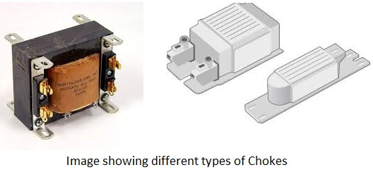

A coil of insulated wire is often wound on a magnetic core to form a choke. As the signal frequency increases, the impedance of the choke increases. Due to its reactance, it can limit the amount AC through it. Even though, practically some amount of AC passes through it due to its low electrical resistance. These are mostly used in tube lights and in transformers in electronic applications.

# **Basic Electronics - Transformers**

According to the principle of **Electromagnetic Induction**, we have already learnt that, a varying flux can induce an EMF in a coil. By the principle of **Mutual induction**, when another coil is brought beside such coil, the flux induces EMF into the second coil.

Now, the coil which has the varying flux is called as the **Primary Coil** and the coil into which EMF is induced is called as the **Secondary Coil**, while the two coils together makes a unit called as a **Transformer**.

## Transformer

A transformer has a primary coil to which input is given and a secondary coil from which the output is collected. Both of these coils are wound on a core material. Usually an insulator forms the **Core** of the transformer.

The following figure shows a practical transformer.

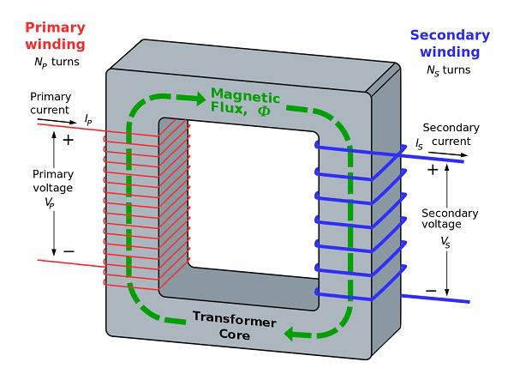

From the above figure, it is evident that few notations are common. Let us try to have a note of them. They are −

* **Np** = Number of turns in the primary winding
* **Ns** = Number of turns in the secondary winding
* **Ip** = Current flowing in the primary of the transformer
* **Is** = Current flowing in the secondary of the transformer
* **Vp** = Voltage across the primary of the transformer
* **Vs** = Voltage across the secondary of the transformer
* **Φ** = Magnetic flux present around the core of the transformer.

### **Transformer in a Circuit**

The following figure shows how a transformer is represented in a circuit. The primary winding, the secondary winding and the core of the transformer are also represented in the following figure.

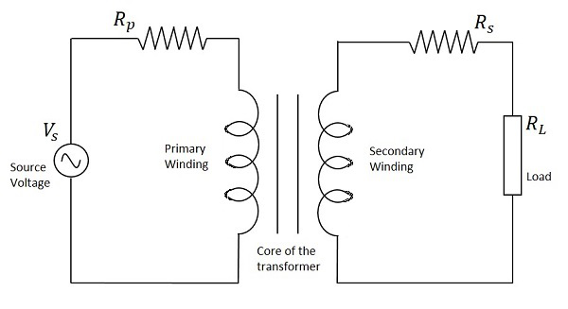

Hence, when a transformer is connected in a circuit, the input supply is given to the primary coil so that it produces varying magnetic flux with this power supply and that flux is induced into the secondary coil of the transformer, which produces the varying EMF of the varying flux. As the flux should be varying, for the transfer of EMF from primary to secondary, a transformer always works on alternating current AC.

## Step-up and Step-down

Depending upon the number of turns in the secondary winding, the transformer can be called as a **Step up** or a **Step down** transformer.

The main point to be noted here is that, there will not be any difference in the primary and secondary **power** of the transformer. Accordingly, if the voltage is high at secondary, then low current is drawn to make the power stable. As well, if the voltage in the secondary is low, then high current is drawn so as the power must be same as the primary side.

### **Step Up**

When the secondary winding has more number of turns than the primary winding, then the transformer is said to be a **Step-up** transformer. Here the induced EMF is greater than the input signal.

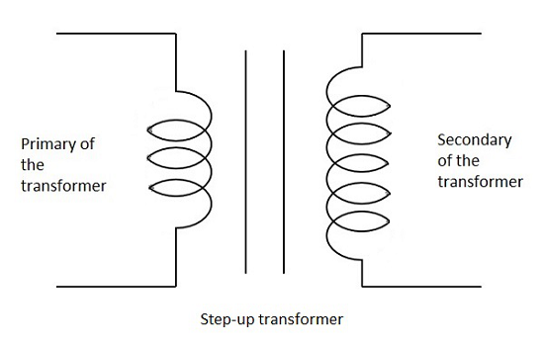

### **Step Down**

When the secondary winding has lesser number of turns than the primary winding, then the transformer is said to be a **Step-down** transformer. Here the induced EMF is lesser than the input signal.

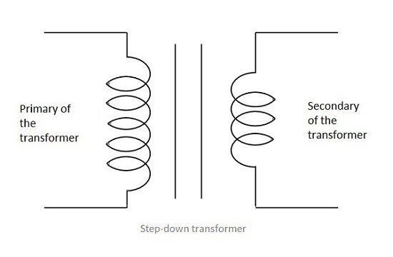

## Turns Ratio

As the number of turns of primary and secondary windings affect the voltage ratings, it is important to maintain a ratio between the turns so as to have an idea regarding the voltages induced.

The ratio of number of turns in the primary coil to the number of turns in the secondary coil is called as the “**turns ratio**” or “**the ratio of transformation**”. The turns ratio is usually denoted by **N**.

N=Turnsratio=NumberofturnsonPrimaryNumberofturnsonSecondary=NpNsN=Turnsratio=NumberofturnsonPrimaryNumberofturnsonSecondary=NpNs

The ratio of the primary to the secondary, the ratio of the input to the output, and the turns ratio of any given transformer will be the same as its **voltage ratio**. Hence this can be written as

NpNs=VpVs=N=TurnsratioNpNs=VpVs=N=Turnsratio

The turns ratio also states whether the transformer is a step-up or a step-down transformer. For example, a turns ratio of 1:3 states that the transformer is a step-up and the ratio 3:1 states that it is a step-down transformer.

# **Basic Electronics - Types of Transformers**

Coming to the classification of transformers, there are many types depending upon the core used, windings used, place and type of usage, voltage levels etc.

## Single and three phase transformers

According to the supply used, the transformers are mainly classified as **Single phase** and **three phase** transformers.

* A normal transformer is a single phase transformer. It has a primary and a secondary winding and it is operated to either decrease or increase the secondary voltage.
* For a three phase transformer, three primary windings are connected together and three secondary windings are connected together.

A single three phase transformer is preferred to three single phase transformers so as to get good efficiency, where it occupies less space at low cost. But due to the transportation problem of heavy equipment, single phase transformers are used in most cases.

Another classification of these transformers is **Core** and **Shell** type.

* In **Shell type**, the windings are positioned on a single leg surrounded by the core.
* In **Core type**, they are wounded on different legs.

The difference is well known by having a look at the following figure.

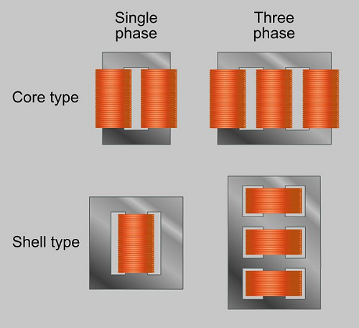

The classification of transformers can also be done depending upon the type of core material used. These are actually **RF transformers**, which contain many types such as Air-core transformers, **Ferrite core** transformers, **Transmission line** transformers and **Balun** transformers. Balun transformers are used in RF receiver systems. The main types are the air core and iron core transformers.

## Air-core Transformer

This is a core type transformer in which the windings are wound on a non-magnetic strip. The magnetic flux linkages are made through **air as core** between the primary and secondary. The following image shows an air-core transformer.

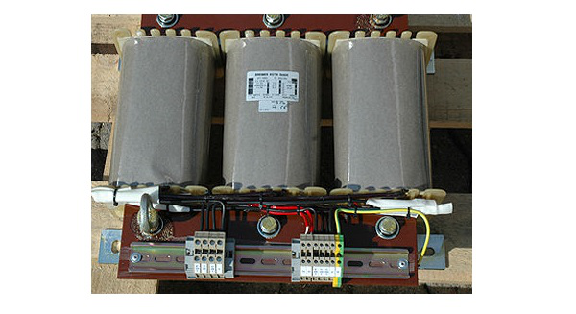

### **Advantages**

* The hysteresis and eddy current losses are low in these Air core transformers.
* Noise production is low.

### **Disadvantages**

* The reluctance is high in Air core transformers.
* Mutual inductance is low in Air core compared to Iron-core transformers.

### **Applications**

* Audio frequency transformers.
* High frequency radio transmissions.

## Iron Core Transformers

This is a core type transformer in which the windings are wound on an iron core. The magnetic flux linkages are made strong and perfect with iron as core material. This is commonly seen in laboratories. The figure below shows an example of iron core transformer.

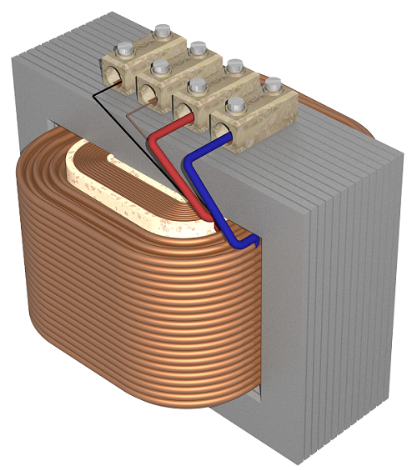

### **Advantages**

* They have very high magnetic permeability.
* Iron core transformers has low reluctance.
* Mutual Inductance is high.
* These transformers are highly efficient.

### **Disadvantages**

* These are a bit noisy compared to Air core transformers.
* The hysteresis and eddy current losses are a bit more than Air core transformers.

### **Applications**

* As isolation transformers.
* High frequency radio transmissions.

The transformers are also classified according to the type of core they use. Some transformers use the core immersed in oil. This oil is cooled from outside by various methods. Such transformers are named as **Wet core transformers**, while the others such as ferrite core transformers, laminated core transformers, toroidal core transformers and cast resin transformers are **Dry core transformers**.

Based on the type of winding technique, we have another transformer which is very popular named as the **Auto transformer**.

## Auto Transformer

This is type of transformer which is mostly seen in our electrical laboratories. This auto transformer is an improved version of the original transformer. A single winding is taken to which both the sides are connected to power and the ground. Another variable tapping is made by whose movement secondary of the transformer is formed.

The following figure shows the circuit of an auto-transformer.

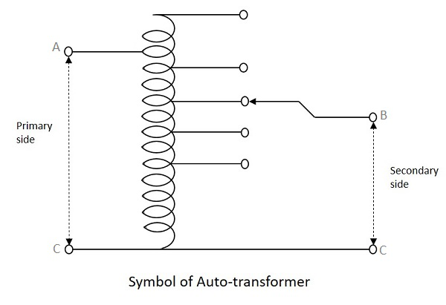

As shown in the figure, a single winding provides both primary and secondary in a transformer. Various tapping of secondary winding are drawn to select various voltage levels at the secondary side.

The primary winding as shown above is from A to C and the secondary winding is from B to C whereas the variable arm B is varied to get the required voltage levels. A practical auto transformer looks like the figure below.

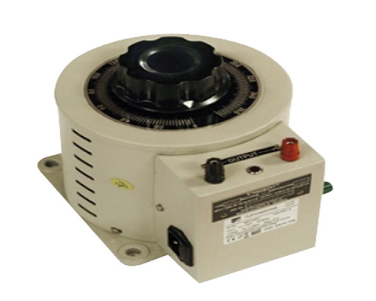

By rotating the shaft above, the secondary voltage is adjusted to different voltage levels. If the voltage applied across the points A and C is V1, then the voltage per turn in this winding will be

Voltageperturn=V1N1Voltageperturn=V1N1

Now, the voltage across the points B and C will be

V2=V1N1×N2V2=V1N1×N2

V2V1=N2N1=constant(sayK)V2V1=N2N1=constant(sayK)

This constant is nothing but the turns ratio or voltage ratio of the auto transformer.

# **Transformers based on Usage**

There are transformers which are classified depending upon the applications they have. Many of these transformers are large and bulky. Most of them are used by the Electricity department.

## Power Transformers

The Power transformers are used in **high power transfer applications** for both step-up and step-down applications, where the operating voltages are more than 33KV generally rated above 200MVA. The flux density is much higher for them.

All the transformers that are used for power control applications such as laminated core transformers, toroidal transformers, variable auto transformers, polyphaser transformers, stray leakage transformers come under this category.

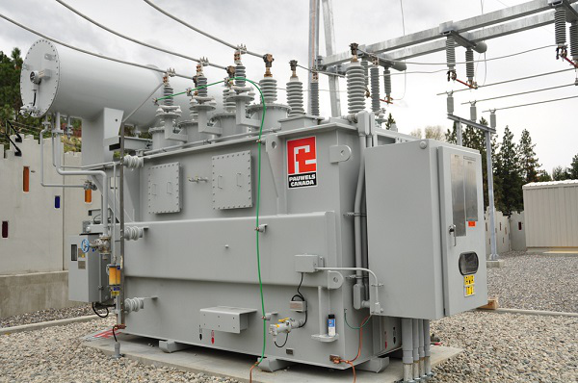

These are usually big in size depending upon the power handling capacity and its application. These transformers are available in three phase or single phase type. As these transformers are bulky, they are placed in large open area. These transformers tend to provide 100% efficiency in full load applications.

### **Advantages**

* They have high insulation level.
* Noise is low.
* They are highly efficient.
* High voltage rated ones to handle high power applications.

### **Applications**

* They are used in power generation systems.
* They are used in transmission sub stations.

## Measurement Transformers

The Measurement transformers are used for measuring high voltage and high currents. These are mostly helpful in isolating the circuits from them. Usually, the Primary of a transformer is connected with high inputs of voltages and currents whereas Secondary of the transformer is connected to some relay or circuit which has to be provided some isolation.

These are mainly of two types, **Current transformers** and **Voltage transformers**. Let us have a look at each of them.

### **Current Transformer**

The Current transformers provide current in the secondary circuit proportional to the current in the primary circuit. These are used in protective relays and for measurement purposes.

A single turn primary winding is passed through a well-insulated toroidal core transformer which is wounded with many turns, which makes a **Current Transformer**. This is always connected in series.

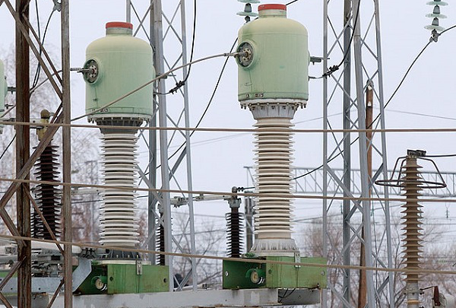

The secondary winding can be designed to provide single output or it may have several tapping for different values. Care must be taken that the secondary winding is connected to its load having low impedance, while current flows in primary. This is to avoid sudden high voltages in open circuited secondary which might permanently damage the accuracy of the transformer.

### **Voltage Transformers**

The Voltage Transformers provide voltage in the secondary circuit proportional to the voltage in the primary circuit. These transformers are also called as **Potential Transformers**. These are connected in parallel to the circuit.

The primary of this transformer may have phase to phase connections but the secondary will have one terminal to ground. The figure below shows an image of a voltage transformer.

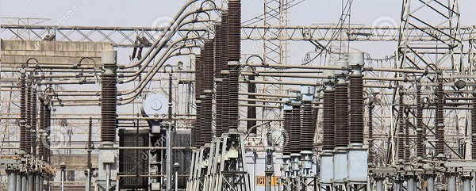

There are three main types of a voltage transformers. They are

* **Electromagnetic** − uses a wire wound transformer having good flux linkages.
* **Capacitor** − uses a capacitor with potential divider network.
* **Optical** − makes use of electrical properties of optical materials.

The voltage transformers are used in protective relays and for measurement purposes and also for phasor phase shift isolation.

### **Protection Transformers**

These transformers are very accurate than measuring transformers, as these are used only to protect the circuits from high voltages and currents. The primary of these transformers are connected with high inputs whereas the secondary of the transformer keeps the circuit or relay, isolated from the sudden spikes or surges which might damage the circuit.

## Distribution Transformers

The Distribution transformers are used for distribution of electrical energy at end-user level. The operating voltages are around 33KV for industrial purposes and 440v-220v for domestic purposes. These are generally rated below 200MVA.

The large three phase auto transformers used in power distribution and the oil-cooled transformers also come under this category. The figure below shows an image of a distribution transformer.

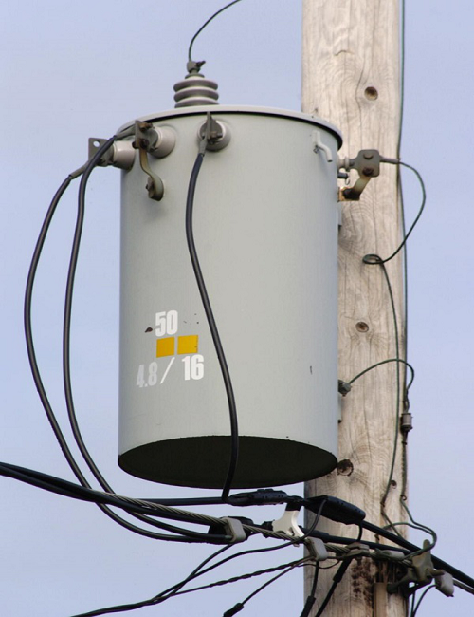

These transformers are usually smaller in size compared to power transformers. These transformers are placed in open but are not fully loaded like power transformers.

### **Advantages**

* They are small in size.
* They are easy to install.
* These transformers have low magnetic losses.

### **Disadvantages**

* These transformers have low efficiency.
* They are not fully-loaded.

### **Applications**

They are used for distributing electricity in various areas like houses, farm yards, lands, railways, wind farms etc.

# **Basic Electronics - Transformer Efficiency**

When the Primary of a transformer has some voltage induced, then the magnetic flux created in the primary is induced into the secondary due to mutual induction, which produces some voltage into the secondary. The strength of this magnetic field builds up as the current rises from zero to maximum value which is given by dφdtdφdt.

The magnetic lines of flux pass through the secondary winding. The number of turns in the secondary winding determines the voltage induced. Hence the amount of voltage induced will be determined by

NdφdtNdφdt

Where N = number of turns in the secondary winding

The frequency of this induced voltage will be same as the frequency of primary voltage. The peak amplitude of the output voltage will be affected if the magnetic losses are high.

## Induced EMF

Let us try to draw some relationship between induced EMF and number of turns in a coil.

Let us now assume that both the primary and the secondary coils has a single turn each. If one volt is applied to one turn of the primary with no losses idealcaseidealcase the current flow and magnetic field generated induce the same one volt in the secondary. Hence voltage is same on both sides.

But the magnetic flux varies sinusoidally which means,

ϕ=ϕmaxsinωtϕ=ϕmaxsin⁡ωt

Then the basic relationship between induced EMF and coil winding of N turns is

EMF=turns×rateofchangeEMF=turns×rateofchange

E=NdϕdtE=Ndϕdt

E=N×ω×ϕmax×cos(ωt)E=N×ω×ϕmax×cos⁡(ωt)

Emax=NωϕmaxEmax=Nωϕmax

Erms=Nω2–√×ϕmax=2π2–√×f×N×ϕmaxErms=Nω2×ϕmax=2π2×f×N×ϕmax

Erms=4.44fNϕmaxErms=4.44fNϕmax

Where

f = flux frequency in Hertz = ω2πω2π

N = number of coil windings

∅ = flux density in webers

This is known as **Transformer EMF Equation**.

As alternating flux produces current in the secondary coil, and this alternating flux is produced by alternating voltage, we can say that only an alternating current AC can help a transformer work. Hence **a transformer doesn’t work on DC**.

## Losses in Transformers

Any Device has few losses in practical applications. The main losses that occur in the transformers are Copper losses, Core losses and Flux leakage.

### **Copper Losses**

Copper loss is the loss of energy, due to the heat produced by the current flow through the windings of the transformers. These are also called as “**I2R losses**” or “I squared R losses” as the energy lost per second increases with the square of the current through the winding and is proportional to the electrical resistance of the winding.

This can be written in an equation as

IPRP+ISRSIPRP+ISRS

Where

* ***IP*** = Primary Current
* ***RP*** = Primary Resistance
* ***IS*** = Secondary Current
* ***RS*** = Secondary Resistance

### **Core Losses**

Core Losses are also called as **Iron Losses**. These losses depends upon the core material used. They are of two types namely, **Hysteresis** and **Eddy Current losses**.

* **Hysteresis Loss** − The AC induced in the form of magnetic flux keeps on fluctuating likeriseandfallslikeriseandfalls and reversing the direction according to the AC voltage induced. Some energy is lost in the core due to these random fluctuations. Such loss can be termed as **Hysteresis loss**.
* **Eddy Current Loss** − While this whole process goes on, some currents are induced in the core which circulate continuously. These currents produce some loss called as **Eddy Current Loss**. Actually the varying magnetic field is supposed to induce current only in the secondary winding. But it induces voltages in the nearby conducting materials also, which results in this loss of energy.
* **Flux Leakage** − Though the flux linkages are strong enough to produce the required voltage, there will be some flux which gets leaked in practical applications and hence results in the energy loss. Though this is low, this loss is also countable when it comes to high energy applications.

## Power of a Transformer

When an ideal transformer is considered with no losses, the Power of the transformer will be constant, as the product when voltage **V** multiplied by current **I** is constant.

We can say that the power in the primary equals the power in the secondary as the transformer takes care of that. If the transformer, steps-up the voltage then the current is reduced and if the voltage is stepped-down, the current is increased so as to maintain the output power constant.

Hence the primary power equals the secondary power.

PPrimary=PSecondaryPPrimary=PSecondary

VPIPcosϕP=VSIScosϕSVPIPcos⁡ϕP=VSIScos⁡ϕS

Where **∅P** = Primary phase angle and **∅S** = Secondary phase angle.

## Efficiency of a transformer

The amount or the intensity of Power loss in a transformer, determines the efficiency of the transformer. The efficiency can be understood in terms of power loss between primary and secondary of a transformer.

Hence, the ratio of power output of secondary winding to the power input of primary winding can be stated as the **Efficiency of the transformer**. This can be written as

Efficiency=PoweroutputPowerinput×100%Efficiency=PoweroutputPowerinput×100%

Efficiency is generally denoted by **η**. The above given equation is valid for an ideal transformer where there will be no losses and the whole energy in the input gets transferred to the output.

Hence, if losses are considered and if the efficiency is calculated in practical conditions, the below equation is to be considered.

Efficiency=PoweroutputPoweroutput+Copperlosses+Corelosses×100%Efficiency=PoweroutputPoweroutput+Copperlosses+Corelosses×100%

Otherwise, it can also be written as

Efficiency=Powerinput−LossesPowerinput×100Efficiency=Powerinput−LossesPowerinput×100

1−LossesInputPower×1001−LossesInputPower×100

It is to be noted that the input, output and losses are all expressed in terms of power, i.e., in Watts.

### **Example**

Consider a transformer having input power of 12KW which is rated at 62.5 amps current having equivalent resistance of 0.425ohms. Calculate the efficiency of the transformer.

**Solution −**

Given data

* Input power = 12KW
* Rated current = 62.5 Amps
* Equivalent resistance = 0.425 ohms

Calculating the loss −

The copper loss at rated current is I2R = 62.562.52 0.4250.425 = 1660W

We have

Efficiency=Powerinput−LossesPowerinput×100Efficiency=Powerinput−LossesPowerinput×100

Hence,

η=12000−166012000×100η=12000−166012000×100

η=1034012000×100η=1034012000×100

η=0.861×100=86%η=0.861×100=86%

Hence the efficiency of the transformer is 86%.

# **Basic Electronics - Diodes**

After having known about various components, let us focus on another important component in the field of electronics, known as a **Diode**. A semiconductor diode is a two terminal electronic component with a PN junction. This is also called as a **Rectifier**.

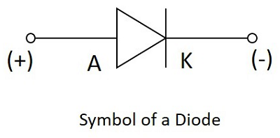

The **anode** which is the **positive terminal** of a diode is represented with **A** and the **cathode**, which is the **negative terminal** is represented with **K**. To know the anode and cathode of a practical diode, a fine line is drawn on the diode which means cathode, while the other end represents anode.

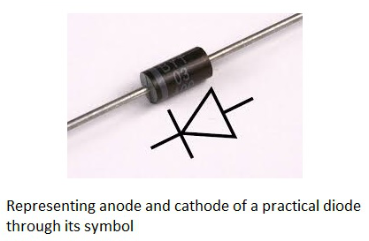

As we had already discussed about the P-type and N-type semiconductors, and the behavior of their carriers, let us now try to join these materials together to see what happens.

## Formation of a Diode

If a P-type and an N-type material are brought close to each other, both of them join to form a junction, as shown in the figure below.

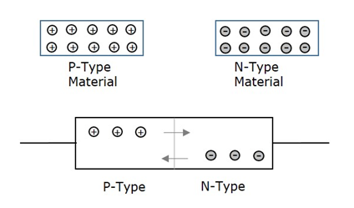

A P-type material has **holes** as the **majority carriers** and an N-type material has **electrons** as the **majority carriers**. As opposite charges attract, few holes in P-type tend to go to n-side, whereas few electrons in N-type tend to go to P-side.

As both of them travel towards the junction, holes and electrons recombine with each other to neutralize and forms ions. Now, in this junction, there exists a region where the positive and negative ions are formed, called as PN junction or junction barrier as shown in the figure.

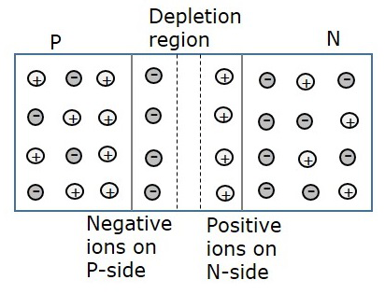

The formation of negative ions on P-side and positive ions on N-side results in the formation of a narrow charged region on either side of the PN junction. This region is now free from movable charge carriers. The ions present here have been stationary and maintain a region of space between them without any charge carriers.

As this region acts as a barrier between P and N type materials, this is also called as **Barrier junction**. This has another name called as **Depletion region** meaning it depletes both the regions. There occurs a potential difference VD due to the formation of ions, across the junction called as **Potential Barrier** as it prevents further movement of holes and electrons through the junction.

## Biasing of a Diode

When a diode or any two-terminal component is connected in a circuit, it has two biased conditions with the given supply. They are **Forward biased** condition and **Reverse biased** condition. Let us know them in detail.

### **Forward Biased Condition**

When a diode is connected in a circuit, with its **anode to the positive** terminal and **cathode to the negative** terminal of the supply, then such a connection is said to be **forward biased** condition. This kind of connection makes the circuit more and more forward biased and helps in more conduction. A diode conducts well in forward biased condition.

### **Reverse Biased Condition**

When a diode is connected in a circuit, with its **anode to the negative** terminal and **cathode to the positive** terminal of the supply, then such a connection is said to be **Reverse biased** condition. This kind of connection makes the circuit more and more reverse biased and helps in minimizing and preventing the conduction. A diode cannot conduct in reverse biased condition.

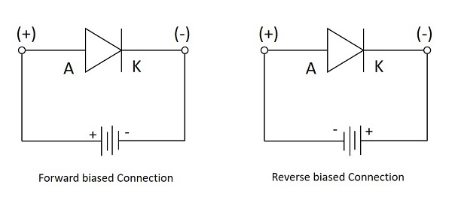

Let us now try to know what happens if a diode is connected in forward biased and in reverse biased conditions.

## Working under Forward Biased

When an external voltage is applied to a diode such that it cancels the potential barrier and permits the flow of current is called as **forward bias**. When anode and cathode are connected to positive and negative terminals respectively, the holes in P-type and electrons in N-type tend to move across the junction, breaking the barrier. There exists a free flow of current with this, almost eliminating the barrier.

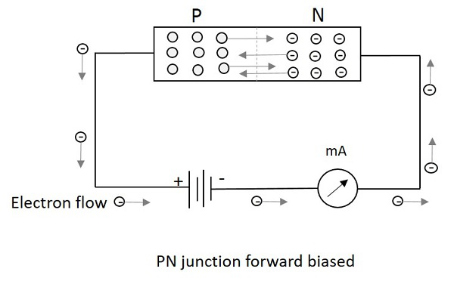

With the repulsive force provided by positive terminal to holes and by negative terminal to electrons, the recombination takes place in the junction. The supply voltage should be such high that it forces the movement of electrons and holes through the barrier and to cross it to provide **forward current**.

Forward Current is the current produced by the diode when operating in forward biased condition and it is indicated by **If**.

## Working under Reverse Biased

When an external voltage is applied to a diode such that it increases the potential barrier and restricts the flow of current is called as **Reverse bias**. When anode and cathode are connected to negative and positive terminals respectively, the electrons are attracted towards the positive terminal and holes are attracted towards the negative terminal. Hence both will be away from the potential barrier **increasing the junction resistance** and preventing any electron to cross the junction.

The following figure explains this. The graph of conduction when no field is applied and when some external field is applied are also drawn.

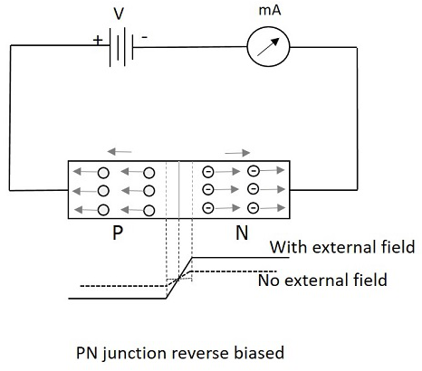

With the increasing reverse bias, the junction has few minority carriers to cross the junction. This current is normally negligible. This reverse current is almost constant when the temperature is constant. But when this reverse voltage increases further, then a point called **reverse breakdown occurs**, where an avalanche of current flows through the junction. This high reverse current damages the device.

**Reverse current** is the current produced by the diode when operating in reverse biased condition and it is indicated by **Ir**. Hence a diode provides high resistance path in reverse biased condition and doesn’t conduct, where it provides a low resistance path in forward biased condition and conducts. Thus we can conclude that a diode is a one-way device which conducts in forward bias and acts as an insulator in reverse bias. This behavior makes it work as a rectifier, which converts AC to DC.

### **Peak Inverse Voltage**

Peak Inverse Voltage is shortly called as **PIV**. It states the maximum voltage applied in reverse bias. The Peak Inverse Voltage can be defined as “**The maximum reverse voltage that a diode can withstand without being destroyed**”. Hence, this voltage is considered during reverse biased condition. It denotes how a diode can be safely operated in reverse bias.

## Purpose of a Diode

A diode is used to block the electric current flow in one direction, i.e. in forward direction and to block in reverse direction. This principle of diode makes it work as a **Rectifier**.

For a circuit to allow the current flow in one direction but to stop in the other direction, the rectifier diode is the best choice. Thus the **output** will be **DC** removing the AC components. The circuits such as half wave and full wave rectifiers are made using diodes, which can be studied in **Electronic Circuits** tutorials.

A diode is also used as a **Switch**. It helps a faster ON and OFF for the output that should occur in a quick rate.

## V - I Characteristics of a Diode

A Practical circuit arrangement for a PN junction diode is as shown in the following figure. An ammeter is connected in series and voltmeter in parallel, while the supply is controlled through a variable resistor.

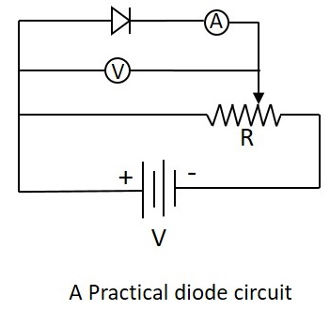

During the operation, when the diode is in forward biased condition, at some particular voltage, the potential barrier gets eliminated. Such a voltage is called as **Cut-off Voltage** or **Knee Voltage**. If the forward voltage exceeds beyond the limit, the forward current rises up exponentially and if this is done further, the device is damaged due to overheating.

The following graph shows the state of diode conduction in forward and reverse biased conditions.

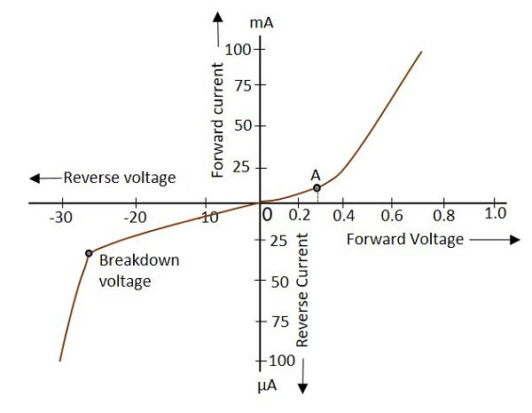

During the reverse bias, current produced through minority carriers exist known as “**Reverse current**”. As the reverse voltage increases, this reverse current increases and it suddenly breaks down at a point, resulting in the permanent destruction of the junction.

# **Basic Electronics - Junction Diodes**

There are many types of diodes depending upon many factors such as the frequency used, their working and construction, their applications etc. Let us go through few of them.

### **Junction diodes**

The junction diodes are the normal PN junction diodes but differ in construction. There are three types of junction diodes, as shown in the following figure.

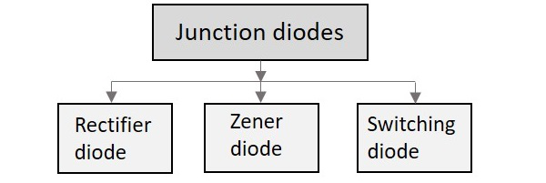

## Rectifier Diode

These diodes are the normal PN junction diodes, which allow current to flow through them in only one direction and stop in the other direction. These diodes are used in rectifier circuits to convert alternating current into direct current.

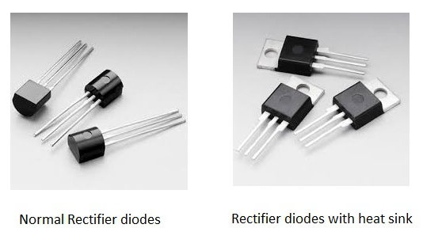

In the above figure, we can see the same rectifier diodes with a metal projection. This is added to the diode to minimize the heat distribution which might affect the diode sometimes. Such a metal projection is called as **Heat sink**. These help in the improvement of the diode performance and the diodes will be able to withstand high powers, without getting affected.

There are circuits such as **Half wave rectifier** and **Full wave rectifier** circuits which use these diodes. These circuits are discussed in ELECTRONIC CIRCUITS tutorial. These rectifier circuits are used in Power supply sections of many circuits where alternating input current has to be converted into direct current for that circuit applications.

## Zener Diode

This is a special kind of diode which permits current flow not only in forward direction, but also in reverse direction. A normal diode, when operated in reverse bias, gets damaged if the reverse current above a certain value is passed through it. This “certain value” is called as the **Breakdown voltage**.

The breakdown voltage of a Zener diode is very low. But **this diode allows the reverse current to pass through it, once this breakdown voltage is exceeded**. That breakdown voltage is called as **Zener Voltage**. Hence there is a controlled breakdown which does not damage the diode when a reverse current above the Zener voltage passes through a Zener diode.

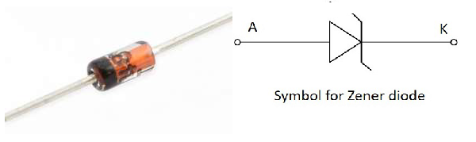

A Zener diode in its reverse bias, exhibits a controlled breakdown voltage and it allows the current flow to keep the value of voltage across that Zener diode close to the Zener breakdown voltage value. This value of Zener breakdown voltage makes any Zener diode to be chosen for certain applications.

**Avalanche diode** is another diode which has the similar characteristics of Zener diode. The avalanche breakdown takes place across the entire PN junction, when the voltage drop is constant and is independent of current. This avalanche diode is used for photodetection.

### **V-I Characteristics of a Zener diode**

The V-I Characteristics of a Zener diode are common for any diode when operated in forward bias. But the reverse bias operation of a Zener diode makes it very important to consider. Let us have a look at the graph.

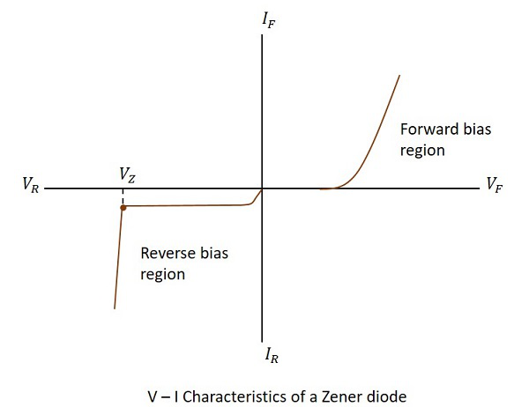

The point where the bent is shown in the reverse bias operation, is the **Zener breakdown voltage**, after which the diode allows high reverse currents through it. This Zener voltage is indicated by **VZ**. This incredible quality of Zener diode made it the most reliable one and have got many applications too.

### **Applications of Zener diode**

This diode has many applications such as −

* It is mostly used as a Voltage Regulator.
* Provides fixed reference voltage in transistor biasing circuits.
* For peak clipping or limiting in wave shaping circuits.
* As a Surge protector in many circuits.
* For meter protection against damage from accidental applications.

## Switching Diode

This is a normal single PN junction diode which is especially designed for switching purposes. This diode can exhibit two states of high and low resistance clearly which can be used alternatively.

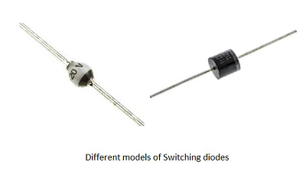

The junction capacitance of this diode is made very low so as to minimize other effects. The switching speed is made quite high. When the diode has high resistance it works as an open switch and it acts as a closed switch during low resistance. This transition occurs at a faster rate in switching diode, than in any ordinary one.

### **Applications of switching diode**

These have many applications such as −

* Used in high-speed rectifying circuits
* Used in ring modulators
* Used in radio frequency receivers
* Used as reverse polarity protectors
* Used for both General purpose and high speed switching applications

# **Basic Electronics - Special Purpose Diodes**

There are few diodes which are designed to serve some special purposes. There are many of such kinds like Transient voltage suppression diodes, Gold doped diodes, Super barrier diodes, Point contact diodes, Peltier diodes etc. But other than these, there are few prominent diodes, which have got many applications. Let us go through them.

## Varactor Diode

A junction diode has two potentials on both sides where the depletion region can act as a dielectric. Hence there exists a capacitance. The Varactor diode is a special case diode that is operated in reverse bias, where the junction capacitance is varied.

The Varactor diode is also called as **Vari Cap** or **Volt Cap**. The following figure shows a Varactor diode connected in reverse bias.

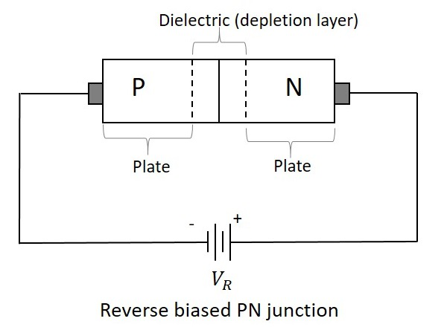

If the reverse voltage applied is increased, the **width** of the dielectric region **increases**, which **reduces** the **junction capacitance**. When the reverse voltage decreases, the width of the dielectric decreases, which increases the capacitance. If this reverse voltage is completely null, then the **capacitance** will be at its **maximum**.

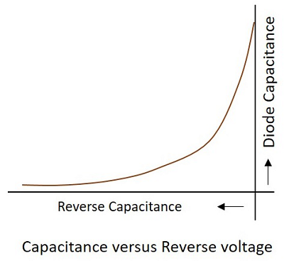

The following figure shows various symbols used for Varactor diode which represents its function.

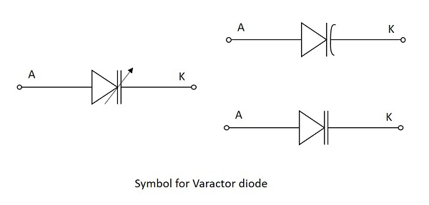

Though all diodes have this junction capacitance, the Varactor diode is mainly manufactured to make use of this effect and increase the variations in this junction capacitance.

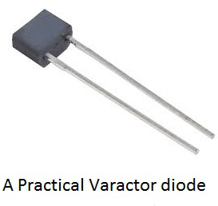

### **Applications of Varactor diode**

This diode has many applications such as −

* It is used as a Voltage variable capacitor.
* It is used in variable LC tank circuit.
* Used as Automatic frequency control.
* Used as Frequency Modulator.
* Used as RF Phase shifter.
* Used as frequency multiplier in local oscillator circuits.

## Tunnel diode

If the impurity concentration of a normal PN junction is highly increased, this **Tunnel diode** is formed. It is also known as **Esaki diode**, after its inventor.

When the impurity concentration in a diode increases, the width of depletion region decreases, extending some extra force to the charge carriers to cross the junction. When this concentration is further increased, due to less width of the depletion region and the increased energy of the charge carriers, they penetrate through the potential barrier, instead of climbing over it. This penetration can be understood as **Tunneling** and hence the name, **Tunnel diode**.

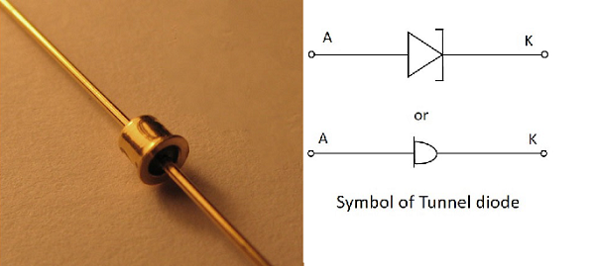

The Tunnel diodes are low power devices and should be handled with care as they easily get affected by heat and static electricity. The Tunnel diode has specific V-I characteristics which explain their working. Let us have a look at the graph below.

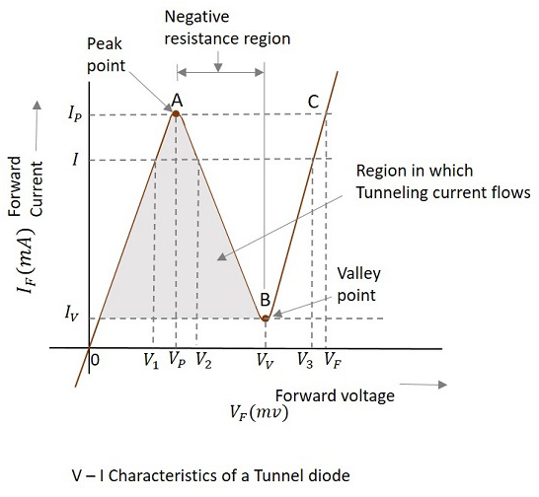

Consider the diode is in **forward-biased condition**. As forward voltage increases, the current increases rapidly and it increases until a peak point, called as **Peak Current**, denoted by **IP**. The voltage at this point is called as **Peak Voltage**, denoted by **VP**. This point is indicated by **A** in the above graph.

If the voltage is further increased beyond **VP**, then the current starts decreasing. It decreases until a point, called as **Valley Current**, denoted by **IV**. The voltage at this point is called as **Valley Voltage**, denoted by **VV**. This point is indicated by **B** in the above graph.

If the voltage is increased further, the current increases as in a normal diode. For larger values of forward voltage, the current increases further beyond.

If we consider the diode is in **reverse-biased condition**, then the diode acts as an excellent conductor as the reverse voltage increases. The diode here acts as in a negative resistance region.

### **Applications of Tunnel diode**

There are many applications for tunnel diode such as −

* Used as a high-Speed Switching device
* Used as a memory storage device
* Used in Microwave oscillators
* Used in relaxation oscillators

## Schottky Diode

This is a special type of diode in which a PN junction is replaced by a metal semiconductor junction. The P-type semiconductor in a normal PN junction diode is replaced by a metal and N-type material is joined to the metal. This combination has no depletion region between them. The following figure shows the Schottky diode and its symbol.

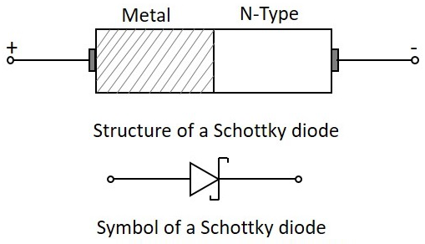

The metal used in this Schottky diode may be gold, silver, platinum or tungsten etc. As well, for the semiconductor material other than silicon, gallium arsenide is mostly used.

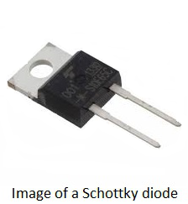

### **Operation**

When no voltage is applied or when the circuit is unbiased, the electrons in the N-type material has lower energy level than the ones in the metal. If the diode is then forward biased, these electrons in the N-type gain some energy and move with some higher energy. Hence these electrons are called as **Hot Carriers**.

The following figure shows a Schottky diode connected in a circuit.

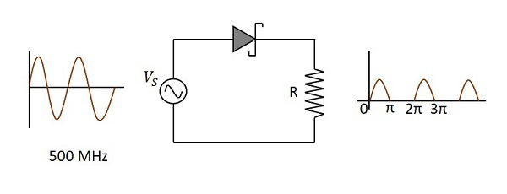

### **Advantages**

There are many advantages of Schottky diode such as −

* It is a unipolar device and hence no reverse currents are formed.
* Its forward resistance is low.
* Voltage drops are very low.
* Rectification is fast and easy with the Schottky diode.
* There is no depletion region present and hence, no junction capacitance. So, the diode gets to OFF position quickly.

### **Applications**

There are many applications of Schottky diode such as −

* Used as a detector diode
* Used as a Power rectifier
* Used in RF mixer circuits
* Used in power circuits
* Used as clamping diodes

# **Basic Electronics - Optoelectronic Diodes**

These are the diodes which are operated on light. The word “Opto” means **Light**. There are types that conduction depending upon the light intensity and other types whose conduction delivers some light. Each type has got applications of their own. Let us discuss the prominent types among these ones.

Some diodes conduct according to the intensity of light falls on them. There are two main types of diodes in this category. They are Photo diodes and Solar cells.

## Photo Diode

Photo diode, as the name implies, is a PN junction which works on light. The intensity of light affects the level of conduction in this diode. The photo diode has a P type material and an N-type material with an **intrinsic** material or a **depletion region** in between.

This diode is generally operated in **reverse bias** condition. The light when focused on the depletion region, electron-hole pairs are formed and flow of electron occurs. This conduction of electrons depends upon the intensity of light focused. The figure below shows a practical Photo diode.

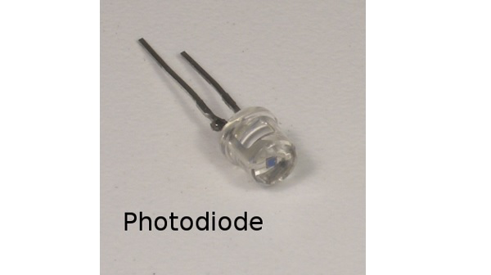

The figure below indicates the symbol for a photodiode.

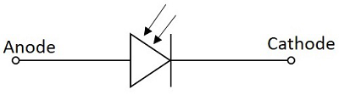

When the diode is connected in reverse bias, a small reverse saturation current flows due to thermally generated electron hole pairs. As the current in reverse bias flows due to minority carriers, the output voltage depends upon this reverse current. As the light intensity focused on the junction increases, the current flow due to minority carriers increase. The following figure shows the basic biasing arrangement of a photo diode.

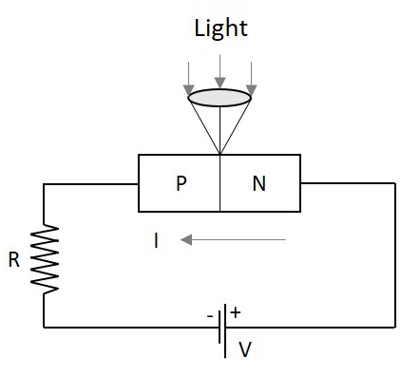

The Photo diode is encapsulated in a glass package to allow the light to fall onto it. In order to focus the light exactly on the depletion region of the diode, a lens is placed above the junction, just as illustrated above.

Even when there is no light, a small amount of current flows which is termed as **Dark Current**. By changing the illumination level, reverse current can be changed.

### **Advantages of Photo diode**

Photo diode has many advantages such as −

* Low noise
* High gain
* High speed operation
* High sensitivity to light
* Low cost
* Small size
* Long lifetime

### **Applications of Photo diode**

There are many applications for photo diode such as −

* Character detection
* Objects can be detected visibleorinvisiblevisibleorinvisible.
* Used in circuits that require high stability and speed.
* Used in Demodulation
* Used in switching circuits
* Used in Encoders
* Used in optical communication equipment

Another diode of such a kind is Solar cell. It is termed as a cell though it is a diode. Let us get into the details.

## Solar Cell

The light dependent diodes include Solar cell, which is a normal PN junction diode but has its conduction by the rush of photons which are converted into the flow of electrons. This is similar to a photo diode but it has another objective of converting maximum incident light into energy and storing it.

The figure below represents the symbol of a solar cell.

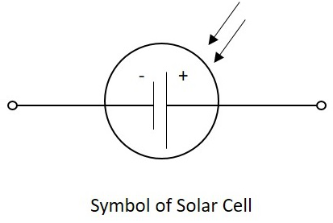

A solar cell has its name and symbol indicating storing of energy though it is a diode. The feature of extracting more energy and storing of it is concentrated in the solar cell.

### **Construction of a Solar cell**

A PN junction diode with an intrinsic material in the deletion region is made to encapsulate in a glass. The light is made to incident on maximum area possible with thin glass on the top so as to collect maximum light with minimum resistance.

The following figure shows the construction of a Solar cell.

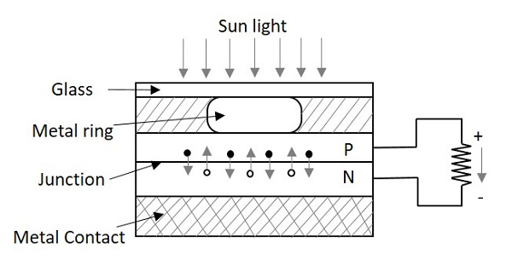

When the light is incident on the solar cell, the photons in the light collide with valence electrons. The electrons are energized to leave the parent atoms. Thus a flow of electrons is generated and this current is directly proportional to the light intensity focused onto the solar cell. This phenomenon is called as the **Photo-Voltaic effect**.

The following figure shows how a solar cell looks like and how a number of solar cells together are made to form a solar panel.

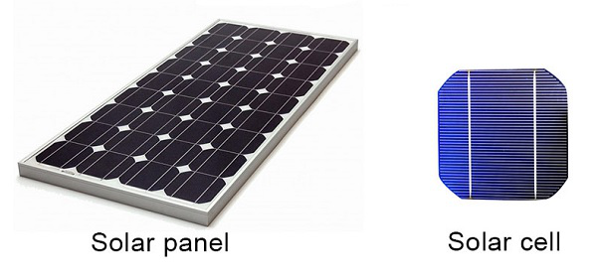

### **Difference between a Photo diode and Solar cell**

Photo Diode works faster and concentrates on switching rather than providing more power at the output. It has a low capacitance value because of this. Also the area of incidence of light energy is lesser in Photo diode, according to its applications.

A Solar cell concentrates on delivering high output energy and storing the energy. This has **high capacitance** value. The operation is a bit slower than photo diode. According to the purpose of the solar cell, the area of incidence of light is larger than photo diode.

### **Applications of Solar Cell**

There are many applications for Solar cell such as −

**Science and Technology**

* Used in Solar panels for Satellites
* Used in telemetry
* Used in Remote lighting systems etc.

**Commercial Use**

* Used in Solar panels for storage of electricity
* Used in Portable power supplies etc.
* Used in household uses such as cooking and heating using solar energy

**Electronic**

* Watches
* Calculators
* Electronic Toys, etc.

Some diodes emit light according to the voltage applied. There are two main types of diodes in this category. They are LEDs and Laser diodes.

## LED LightEmittingDiodesLightEmittingDiodes

This one is the most popular diodes used in our daily life. This is also a normal PN junction diode except that instead of silicon and germanium, the materials like gallium arsenide, gallium arsenide phosphide are used in its construction.

The figure below shows the symbol of a Light emitting diode.

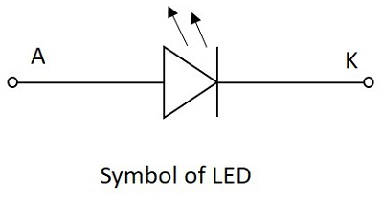

Like a normal PN junction diode, this is connected in forward bias condition so that the diode conducts. The conduction takes place in a LED when the free electrons in the conduction band combine with the holes in the valence band. This process of recombination emits **light**. This process is called as **Electroluminescence**. The color of the light emitted depends upon the gap between the energy bands.

The materials used also effect the colors like, gallium arsenide phosphide emits either red or yellow, gallium phosphide emits either red or green and gallium nitrate emits blue light. Whereas gallium arsenide emits infrared light. The LEDs for non-visible Infrared light are used mostly in remote controls.

The following figure shows a how the practical LEDs of different colors looks like.

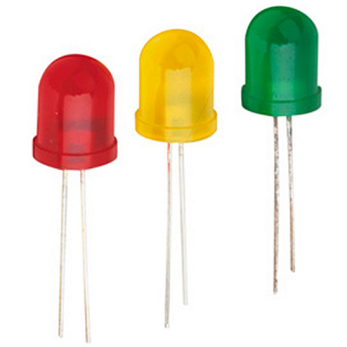

LED in the above figure has a flat side and curved side, the lead at the flat side is made shorter than the other one, so as to indicate that the shorter one is **Cathode** or negative terminal and the other one is **Anode** or the Positive terminal.

The basic structure of LED is as shown in the figure below.

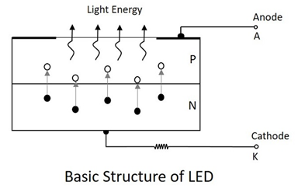

As shown in the above figure, as the electrons jump into the holes, the energy is dissipated spontaneously in the form of light. LED is a current dependent device. The output light intensity depends upon the current through the diode.

### **Advantages of LED**

There are many advantages of LED such as −

* High efficiency
* High speed
* High reliability
* Low heat dissipation
* Larger life span
* Low cost
* Easily controlled and programmable
* High levels of brightness and intensity
* Low voltage and current requirements
* Less wiring required
* Low maintenance cost
* No UV radiation
* Instant Lighting effect

### **Applications of LED**

There are many applications for LED such as −

**In Displays**

* Especially used for seven segment display
* Digital clocks
* Microwave ovens
* Traffic signaling
* Display boards in railways and public places
* Toys

**In Electronic Appliances**

* Stereo tuners
* Calculators
* DC power supplies
* On/Off indicators in amplifiers
* Power indicators

**Commercial Use**

* Infrared readable machines
* Barcode readers
* Solid state video displays

**Optical Communications**

* In Optical switching applications
* For Optical coupling where manual help is unavailable
* Information transfer through FOC
* Image sensing circuits
* Burglar alarms
* In Railway signaling techniques
* Door and other security control systems

Just as LED has many advantages and applications, there is another important diode called Laser diode, which also has got many advanced features and scope of future. Let us discuss about Laser diode.

## Laser Diode

Laser Diode is another popular diode for its kind. This is an optical diode which emits light but with stimulated process. The name **LASER** implies **L**ight **A**mplification by **S**timulated **E**mission of **R**adiation.

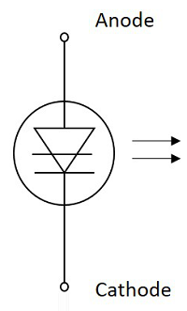

## Stimulated Emission

This is a PN junction diode whose action starts when a light ray is incident on it. With a light ray, when photons get incident on an atom, the atom gets excited and it reaches an upper level which can be termed as a **Higher Energy Level**.

The atom when shifts from the higher energy level to a **Lower Energy Level**, it releases **two photons** which are **similar in characteristics** to the incident photon and are in **equal phase** to it. This process is called as **Stimulated Emission**. An atom can generally stay in this excited state for **10-8 secs** of time.

So, the above process sets the principle for laser diode.

### **Principle of Laser Diode**

Whenever a photon is incident on an atom, that atom is excited from a lower energy state to a higher energy state and two photons are released in this process. Actually, an atom can generally stay at this excited state for **10-8** secs of time. So, in order to achieve amplification, during this excited process, the atom is made to be placed in another state called **Meta Stable State** which is below the higher energy level and above the lower energy level.

An atom can stay in this Meta stable state for **10-3** secs. While the atom gets to the lower state from this, two photons are released. If more number of atoms are there in the excited state, prior to the photons striking the atoms, then we have the **Lasing Effect**.

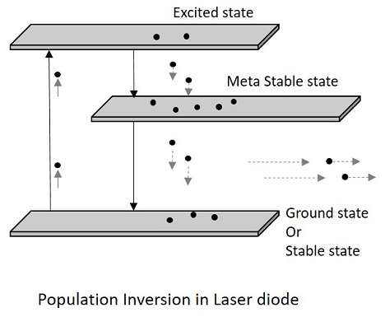

In this process, we have two terms to understand. Having more number of atoms at Meta Stable state than the lower energy state or ground state is called as **Population inversion**. Then energy that lets the atoms to send from a lower energy state to a higher energy state to achieve the population inversion, is called as **Pumping**. This is **Optical pumping**.

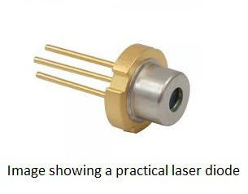

### **Advantages**

There are many advantages of Laser diode such as −

* Power used by laser diodes is much less
* Higher ON/OFF switching speed
* More Compact
* Less expensive
* They are cheaper than laser generators
* Less chances of providing electrical shocks

### **Disadvantages**

There are few disadvantages of Laser diode such as −

* More divergent rays and hence quality is not so good
* Their life time is less compared to LED.
* Prone to damage during unstable power supplies

### **Applications**

There are many applications of Laser diode such as −

* Used as pump-laser and seed-laser
* Used in optical data storage devices
* Used in laser printers and laser fax machines
* Used in Laser pointers
* Used in bar-code readers
* They are used in DVD and CD drives
* Used in HD DVD and BLU RAY technology
* Has many industrial purposes such as heat treating, cladding, seam welding etc.
* Has got many uses in communication technology such as data linking and transmission.

After going through all these, let us try to understand few terms.

### **Component**

* The Components are the individual basic elements of electronics.
* They have different properties with respect to their construction.
* Every component has different applications.

**Ex** − Resistor, Capacitor, Diode etc.

### **Circuit**

* A Circuit is a network of different components
* The components in the circuit altogether, survive an intended purpose.
* If a circuit has to be active, should contain a power source.

**Ex** − clipper and clamper circuits, amplifier circuits, relay circuits etc.

### **Device**

* A Device is an equipment that is made up of different circuits.
* All circuits in the device help it function to serve its purpose.
* A device can be used for measuring signals, generating signals, controlling the outcomes or protecting the circuits and so on.

**Ex** − CRO, Function generator etc.

### **Solid State devices**

Previously we used to have vacuum tubes, which work on thermionic principle and are filled with vacuum inside. They were bigger in size than today’s components. These vacuum tubes were replaced with semiconductor devices, which are also called as **Solid state devices**.

### **Active Devices**

The devices orpreciselycomponentsorpreciselycomponents which can control the current flow can be termed as Active Devices.

* They require some input power supply to get into conduction.
* The working of these components define the behavior of the circuit.

**Ex** − Vacuum tubes, diodes, transistors, SCRs

### **Passive Devices**

The devices orpreciselycomponentsorpreciselycomponents which cannot control the current flow can be termed as Passive Devices.

* They don’t require input power supply to work.
* The working of these components slightly alters the circuit’s behavior.

**Ex** − Resistor, Capacitor, Inductor etc.

### **Doping**

The process of adding of electrons or creating holes to alter the characteristics of the semiconductor material, either by making more positive or by making more negative can be understood as **Doping**.

The applications of diodes include many circuits starting from clipper and clamper circuits, which will be discussed in ELECTRONIC CIRCUITS tutorial.